yuria-pharm
Assessment
report

Introduction 4
Purpose 4
Scope 4
Out of scope 4
Definitions 4
Business overview 6
Business background 6
Problem statement 6
Main business challenges and needs 7
Business goals 8
Applications infrastructure 8
System landscape 8
Data processing 10
Review and documentation of key metrics 11
Metrics 11
Dimensions 13
Data sources 16
Data migration needs 26
Performance requirements and data transfer requirements 26
Data upload requirements 27
Requirements to control the emergence of new objects or changes in structures 27
Requirements for the full data download process 28
Requirements for the incremental data download process 28
Requirements for the accumulation of history and the ability to return to a certain state of the object 29
Users and roles 32
Data classification and related risks 32
Applications infrastructure/networking components 33
As-Is Landscape Error! Bookmark not defined.
Future Landscape 34
Agreed network diagram with UF CISO 36
Security and compliance needs 36
Recommended changes and improvements 37
Resilience, availability, and disaster recovery requirements 38
Data quality policy and framework establishment ingestion 39
Workflows orchestration 41
Single data repository 43
Microsoft Fabric Lakehouse concept 44
BI/ETL software modernization 46
Visual representation of As IS vs future landscape 47
As IS landscape 47
Future landscape 48
Implementation roadmap 49
Assumptions and limitations 51
Budget 52

Introduction

Purpose
The purpose of this document is to present the main findings from the assessment conducted during the DWH Implementation. It also defines the project's boundaries across various dimensions, including approach and roadmap, and serves as an agreement between the project team, the project sponsor, and key stakeholders. This document is intended for both business and technical audiences and does not cover the actual system implementation or provide detailed technical guidelines, projections, or presumptions. The Assessment Report covers both business and technical contexts without focusing specifically on either, emphasizing how the technical system implementation benefits the business. This report includes business challenges and recommendations from the analysis phase, and complements the accompanying documentation, deliverables, and diagrams. It is designed to serve as a guide for future teams and resources in implementing Yuria-Pharm's future state data platform.

Scope
- 7 Systems (1C Front, Gamma, GD Pharm, Microsoft Dynamics AX, Unicorn, SCM, Morion) and 25 related objects
- Applications infrastructure/networking components
- Recommended changes and improvements
- Analysis for requirements preparation
- CI/CD for different environments
- Security and compliance needs
- System landscape design
- Data warehouse with medallion architecture for 8 Business metrics (KPIs)
- Orchestration module
- Data quality module
- Users and roles
- Documentation to the developed system

Out of scope
- Reporting development is not included to the scope of project

Definitions
Definitions and abbreviations
Term | Description
UF | Yuria-Pharm
DWH | Data Warehouse
REST | Representational State Transfer
API | Application Programming Interface
DB | Database
BI | Business Intelligence
ETL | Extract, Transform, Load
ELT | Extract, Load, Transform
BG | Business Goal
AD | Active Directory
ERP | Enterprise Resource Planning
GB | Gigabyte
SCD | Slowly Changing Dimension
VPN | Virtual Private Network
SaaS | Software as а Service
HTTPS | Hypertext Transfer Protocol Secure
RBAC | Role Based Access Control
CDC | Change Data Capture
ODS | Operational Data Store
RAM | Random Access Memory
PaaS | Platform as a Service
DC | Data Center

Business overview

Business background
Yuria-Pharm is an international biopharmaceutical group of companies with Ukrainian roots and global ambitions. Since its foundation in 1998 as a manufacturing company in Cherkasy, Yuria-Pharm has grown into a major player in the pharmaceutical industry, offering innovative medical solutions and transforming the standards of treatment and health improvement worldwide.
Today, Yuria-Pharm is a leading biopharmaceutical corporation specializing in R&D, manufacturing, marketing, and distribution of hospital medicines and medical devices. The corporation reinvests up to 90% of its profits into development, launching around 20 new products annually and maintaining over 600 product registrations in more than 40 countries. Export accounts for approximately 25% of its operations.

The company operates modern production facilities in Ukraine and other countries with a combined annual output exceeding 320 million units. Its R&D centers focus on the development and scaling of technologies for biopharmaceutical active ingredients and innovative formulations, including those based on hyaluronic acid.
Yuria-Pharm holds a 13.4% share in the Ukrainian parenteral drug market and ranks among the top 3 hospital medicine distributors and pharmaceutical companies by turnover in Ukraine. The corporation’s quality management system meets international standards (ISO, GMP), ensuring the safety and efficacy of its products.
With a vertically integrated distribution service, a powerful production base, and a growing international presence, Yuria-Pharm continues to set new standards in biopharma and lead the Ukrainian pharmaceutical industry into the global arena.

Problem statement (Current pain points, challenges, and end user needs) + (Product fit and gaps)
Yuria-Pharm operates a complex and fragmented analytics environment involving multiple data sources, manual processes, and legacy systems. The current reporting ecosystem spans seven systems (1C Front, Gamma, GD Pharm, Microsoft Dynamics AX, Unicorn, SCM, Morion) and 25 related objects, each playing a critical role in sales, production, supply chain, and operational decision-making.
The current DWH suffers from limitations such as duplicate data, incomplete datasets, and overly complex data loading logic, making it difficult to generate reliable business insights. Additionally, the existing system cannot be efficiently scaled or extended to include new indicators, dimensions, or data sources without extensive manual intervention.
As a result, valuable resources are spent maintaining outdated infrastructure rather than focusing on strategic data initiatives. The lack of data governance and clear traceability compromises the accuracy of analytics and hinders timely decision-making. This not only affects operational transparency and product portfolio management but also impedes Yuria-Pharm’s ability to act on opportunities in an increasingly competitive global pharmaceutical market.
To overcome these challenges, there is an urgent need to develop a modern, scalable, and secure DWH using a medallion architecture. This new platform must enable seamless data integration, provide high data quality, ensure compliance with regulatory standards, and serve as a single source of truth for business analytics and strategic decision-making.

Main business challenges and needs(Current pain points, challenges, and end user needs)
Key business challenges
Key Business Challenges | Business Perspective | Technical Perspective
No single source of truth | Difficult to get a complete and accurate picture of the business. | Data is fragmented across 7 different systems with no unified platform.
Legacy DWH limitations | The existing data warehouse does not meet current business needs: data incompleteness, duplication, and complex logic hinder effective analytics and portfolio management. | The current DWH is difficult to maintain: adding new data sources, metrics, or dimensions is nearly impossible; maintenance consumes excessive resources.
Low data quality | Inaccurate or incomplete data negatively impacts the quality of analytics and business insights. | No mechanisms for data quality checks, logging operations, or control notifications.
Business needs
Business Needs | Description
Centralized data storage | Build the DWH as a reliable, centralized source of trusted data for strategic decision-making.
Data Integration | Consolidate and unify data from all key business systems into a single repository.
Product Portfolio Analytics | Enable analysis of product portfolio performance based on complete and consistent data.
Scalability | Support growing data volumes and the addition of new sources.
Processes automation | Reduce manual work in data extraction, transformation, and loading.
Historical data tracking | Accumulate historical data for trend analysis and informed business decisions.

Business goals(Current pain points, challenges, and end user needs)
Considering the existing business challenges the next business goals should be addressed
BG-ID | BG description | BG benefits
BG-01 | Data-driven decision-making | Transition to making faster, more accurate, and efficient decisions based on data.
BG-02 | Process transparency | Create a single source of truth across all users.
BG-03 | Cost optimization | Reduce reporting and analytics costs, minimize duplication and manual efforts.
BG-04 | Data quality improving | By using the advanced data management and analytics tools, Yuria-Pharm will be able to create a single source of truth for its data, improve data quality processes, and achieve consistent compliance throughout its governance process
The implementation of a modern DWH platform will provide Yuria-Pharm with significant strategic and operational advantages. It will enhance data processing capabilities, reduce manual effort and operational costs, and modernize the company’s approach to business processes and technology usage. With advanced data management and analytics tools, the DWH platform will help Yuria-Pharm address key challenges in data governance, ensure data consistency across departments, and support compliance with internal and external regulations. This transformation will empower faster, data-driven decision-making and foster a culture of innovation and efficiency across the organization.

Product fit and gaps to identify which product will best serve the customer’s needs (Треба систематизувати з декількох місць

Problem statement (6)
BI/ETL software modernization (46)
Recommended changes and improvements (37)
Microsoft Fabric Lakehouse concept (44, 45))

Data governance and compliance – Занадто розкидано (трішки в Business goals + Security and compliance + Problem statement)

Applications infrastructure

System landscape(Data storage needs) + Logical architecture
Yuria-Pharm has a multitude of different systems some of which are hosted on-premises and others on cloud.
The company has a data warehouse, based on which reports are built in Power BI. Additionally, there are data-marts (tables that show specific loaded and calculated data) created directly within the warehouse itself.
Challenges with existing DWH: unclear and complex data loading logic into the DWH, duplicate data and incomplete data. Development of the current DWH in terms of adding new data, metrics, and dimensions is practically impossible, which casts doubt on the possibility of obtaining any analytics from the DWH beyond the existing ones. Supporting it consumes a significant portion of the available resources.
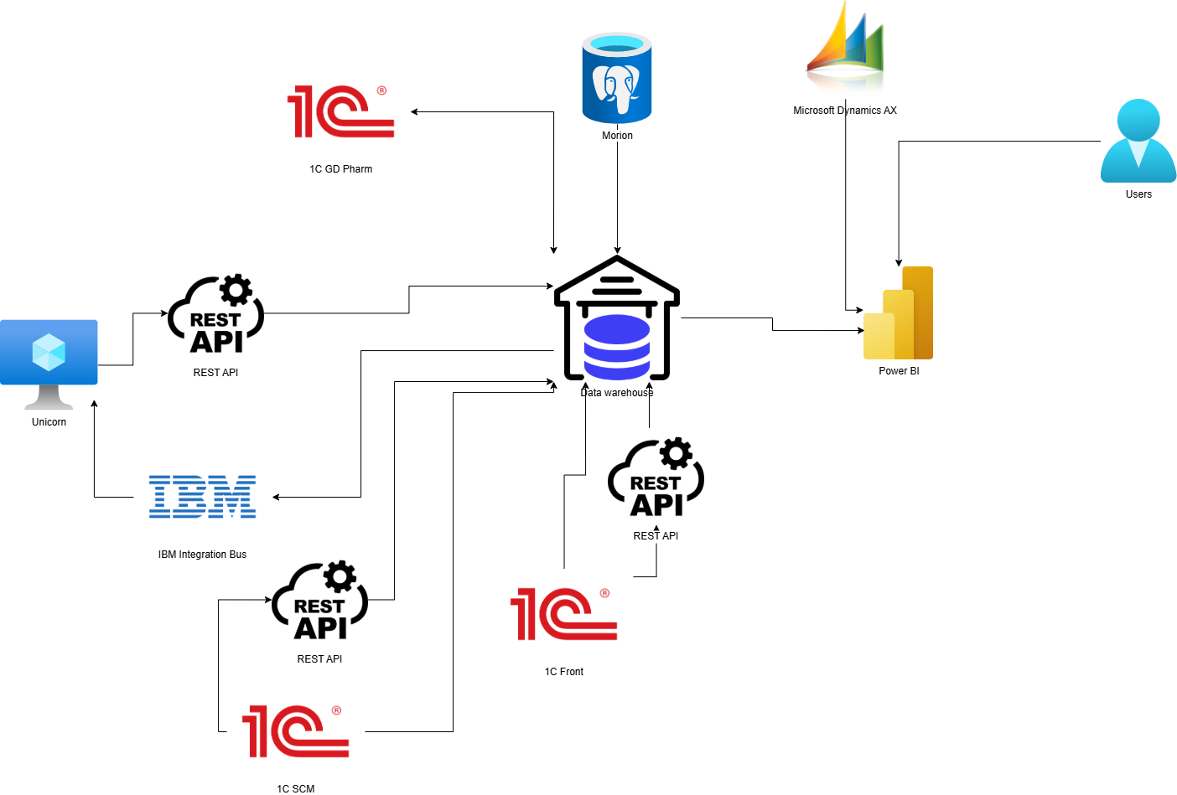

Systems and services (general description of the systems) (Information for all applications, services)
# | System | Description
1 | DWH | The current DWH solution in the Company. It is implemented on the MS SQL Server 2017 database. Holds more than 700 GB of data.
2 | 1C Front | The system is used to store information about clients and create promotions, loyalty measures, gather feedback and other related data.
3 | Dynamics AX (Axapta) | Here is located information about sales, accounting of production, inventory and cash operations.
4 | Gamma | Accounting and creation of numerous documents including - sales, shipping documents, supplier orders, inventory, financial indicators
5 | Unicorn | Product portfolio management (existing products or planned products), market entry, task formulation, setting plans for pre-launch, decision-making process
6 | Morion | System that is used for retail sales management and inventory management, sales, analytics, stock control
7 | GD Pharm | For managing the activities of the distributor GD PHARM located in Uzbekistan. Inventory of goods located at the customs licensed warehouse that do not belong to GD Pharm.
8 | CBT (SCM) | This is a custom version of 1C. It works based on inputs from other systems and used for planning sales, planning the distribution of goods, inventory management and procurement planning.
9 | Power BI | Connected to DWH and used as visualization and reporting tool.
Додати за аналогією таблицю (Identify data sources(on-premises, AWS, Google, etc.) and destination (data storage on Azure))
DS_ID | Group of sources | A specimen | Source type | Current placement | Current network address | port | Authentication type | Destination | Note

Data processing
The main need for the data processing is a medallion architecture, a data design pattern that is going to be used to organize data logically. Its goal is to incrementally and progressively improve the structure and quality of data as it flows through each layer of the architecture (from Bronze ⇒ Silver ⇒ Gold layer tables).
The terms bronze (raw), silver (validated), and gold (enriched) describe the quality of the data in each of these layers. By progressing data through these layers, organizations can incrementally improve data quality and reliability, making it more suitable for business intelligence and machine learning applications.
There are three groups of stakeholders for Data Warehouse:
- The first group consists of database developers and Data Scientists. They will need access to DWH in order to perform data cleaning and validation, build models and perform advanced analytics.
- The second group consists of end report users, and they won’t need access to DWH as the vast majority of them will view the reports through Power BI.
- The third group is data analytics. They require access to reports and to a Data Warehouse to work across multiple layers, such as the Silver and Gold layers, in order to extract valuable insights and generate reports.

At the data ingestion stage (bronze) into the DWH, no data processing will take place, as there is a need to store the data in the repository AS-IS, preserving the original format of each source system.
Data cleanup, validation and transformation are going to be provided at the later stages (silver and gold). And processed using Python notebooks, Spark Jobs in MS Fabric.
In the recommendation section of this document, the Kyivstar team presents their vision on modern cloud integration technology and pipeline testing.

Compatibility (current state vs future state):

Review and documentation of key metrics (Data storage needs)

Metrics
At this stage, eight key sales-related metrics were selected to support portfolio management.
The selected indicators are documented in terms of their definitions, calculation methods and associated data sources to ensure consistency and traceability in subsequent analytical and reporting processes.
The information is structured as follows:
- Definition of Metrics: Names, synonyms, and formal definitions of the metrics.
- Metric Calculation: Formulas and units of measurement associated with each metric.
- Data Sources for Metrics: Source systems and databases from which the metrics are populated.
Definition of metrics
Metric Name | Common Name | Definition
Об'єм продажу | Sales Volume | Represents the number of units of goods or services sold by a company over a specific period of time
Товарообіг/обсяг продажів | Sales Value | The total monetary value of goods and services sold over a specific period. It is a key financial performance metric that helps assess the effectiveness of commercial operations and is a component of Revenue.
План продажів | Sales plan | The amount of products a company plans to sell during a certain period at specified prices.
План - факт продажів | Sales Achievement Percentage | A metric showing how actual sales match the planned sales in the selected comparison scenario (strategic, tactical, etc.) for the chosen analysis period.
Планова ціна реалізації | Planned Selling Price | The expected or target price at which the company plans to sell a product during a certain period. It is defined based on the annual strategic plan, taking into account the main monthly scenario for the product range and regional launches for adjustments.
Фактична ціна реалізації | Actual Selling Price | The real average price at which the product was sold during a certain period, taking into account all discounts, returns, promotions, and commercial terms.
Приріст | Growth | A metric showing the change or dynamics of an metric over a specific period compared to the previous one. It helps to evaluate the company's performance trend.
Темп приросту | Growth rate | A relative metric showing the percentage change of a metric over a specific period compared to the previous one.
Metric calculation
Metric Name | Calculation Formula | Unit of Measurement
Об'єм продажу | ∑ Number of units sold | Quantity, units
Товарообіг/обсяг продажів | ∑ Actual sales revenue | USD
План продажів | Planned quantity × Planned selling price | USD, units, packages
План - факт продажів | Sales /Planned sales *100 | % (USD, units, packages)
Планова ціна реалізації | Planned monetary value / Planned quantity (units/packages) | USD
Фактична ціна реалізації | Actual sales revenue / Number of units sold | USD
Приріст | Current period value − Previous period value | USD, units, packages
Темп приросту | (Current period value / Previous period value × 100%) − 100% | % (USD, units, packages)
Data sources for metrics
Metric Name | Data Sources
Об'єм продажу | 1С Front, GD Pharm, Gamma, Morion, Axapta
Товарообіг/обсяг продажів | 1С Front, GD Pharm, Gamma, Morion, Axapta
План продажів | SCM
План - факт продажів | 1С фронт, GD Pharm, SCM, Gamma, Morion, Axapta
Планова ціна реалізації | SCM
Фактична ціна реалізації | 1С Front, GD Pharm, Gamma, Morion, Axapta
Приріст | Calculated using prior metrics
Темп приросту | Calculated using prior metrics

The listed metrics must be available across all the analytical dimensions specified below, except for specific cases where either:
- the corresponding system does not store the required dimension (e.g., Business Unit is not available in GD Pharm),
- or the dimension is not relevant to the specific metric.
In all other cases, the availability of metrics across the full set of dimensions is required to ensure consistency and comparability of analytical outputs.

Dimensions
The table below describes the key analytical dimensions used in the reporting and data modeling processes. Each dimension is provided with a definition and a list of source systems from which the corresponding data is retrieved.
Dimensions and Source Systems
Dimention Name | Common Name | Description | Data Sources | to historize data
Сегмент | Segment | Responsible for executing marketing activities for a specific brand, group of products, or therapeutic area within the overall marketing strategy of the company. Structurally maintained within the CRM system | SalseForce(Not in scope) | yes
Бізнес Юніт | Business Unit | A structural unit of the company focused on the development of a specific product line, market, or business model with potential for growth, innovation, or expansion into new markets. | 1С Front, GD pharm, Morion, Axapta, SCM  This dimension is missing in Gamma | yes
Юридична особа | Legal Entity | An organization established and registered according to the law, operating under its own name, and bearing responsibilities and obligations towards the law and its counterparties. And interacts with a member of the group of companies | 1С Front, GD pharm, Gamma, Morion, Axapta, SCM
Терапевтичний напрямок | Therapeutic Area | A category of medical conditions or diseases targeted by a particular pharmaceutical product or group of products. Organizationally located within the Growth Directorate. | Unicorn (Product.DCTSbuId -> .DctSBU).  It’s not available for Axapta | yes
Країна продажу | Country of Sale | The territory where the company's product is officially marketed and sold. | 1С Front, GD Pharm, Gamma, Morion, Axapta, SCM
Продукт* | Product | A specific pharmaceutical form, dosage, and packaging of a medicine that holds commercial registration and is available on the market. | Unicorn  (BrandName - производственная группа, ProductName)
Бренд | Brand | Brand is the emotional perception of a product or service’s value by the customer. It is intended to identify and distinguish specific products, services, companies, or organizations from others in the market, as well as to communicate the way a company executes its market strategy. A brand encompasses not only the name but also the values, image, communication style, visual elements, and other characteristics that help build recognition and trust in a product or organization. | Unicorn.DctBrands | yes
Джерело фінансування | Source of Funding | A mechanism or entity responsible for covering the cost of treatment or the drug. For example, hospital sector, retail market, FMCG, etc. | 1С Front, GD Pharm, Gamma, Morion, Axapta, SCM | yes
Номенклатура ГП | Finished Product Nomenclature | A unique product item available on the market, characterized by a specific set of physical attributes that distinguish it from other items within the product catalog. The list of these attributes is determined based on the company's business direction, product type, subtype, and country of registration. Each item is assigned a unique identifier (General ID).  Old definition: A structured list of finished pharmaceutical products available for commercial distribution. | Unicorn (DctSku)
ABC категоризація продажів | ABC Sales Categorization | Uses categorization by Brand and Country. In the future, it will be better integrated with the Manufacturing Group structure. | 1С Front | yes
Регіональне ділення | Regional Division | Represents the region of sale, often corresponding to an administrative region. The information is sourced from the consignee (delivery address), pharmacy, or related entities. | 1С Front, GD Pharm, Gamma, Morion, Axapta, SCM | yes
Період | Period | Represents the actual date of sale, used for reporting and aggregation purposes | 1С Front, GD Pharm, Gamma, Morion, Axapta, SCM | Keep historical versions of sales plans by period (capturing them on the first day of the month is enough)
Виробнича площадка | Production Site | The physical location or facility where the production of finished goods takes place | 1С Front, GD Pharm, Gamma, Morion, Axapta, --->  Unicorn(DctProductionSites.Name)
* needs clarification; currently received from Unicorn, potentially Brand/Production Group

The data necessary to support the described metrics and analytical dimensions must be fully loaded into the system. This includes complete datasets covering the entire available historical depth.

Data sources

The table below summarizes the data loading strategies, synchronization frequency, and object types for each source system involved in the source systems.
Data Source Loading Overview (Data storage needs) + Assess and document application
Source | Object type | Loading Strategy | Data Collection Schedule (Kyiv time)
1C Front | Dimensions: 13 objects  Facts: 3 objects + 7 Factless objects | Update all changed data using hash comparison. For large tables, detect changes by periods or dimensions | 5:00
GD Pharm | Dimensions: 14 objects  Facts: 4 objects | Update all changed data using hash comparison. For large tables, detect changes by periods or dimensions | 4:00 everyday
SCM | Dimensions: 2 objects  Facts: 6 objects | Update all changed data using hash comparison by weekly period. | 4:00 everyday
Unicorn | Dimensions: 22 objects  Facts: 0 objects | Full Load | 3:00 everyday
Morion | Dimensions: 7 objects  Facts: 4 objects in each of the 52 schemes via 1 select statement ingested into 1 table | Update all changed data using hash comparison by weekly period. | 4:00 everyday
Gamma | Dimensions: 0 objects  Facts: 1 object | Update all changed data for the current and previous month | 8:10 everyday
Axapta | Dimensions: 4  Facts: 3 | Full load daily at 04:00–05:00. Hash check TBD; partitioning by date/dimension if needed. | 4:00 everyday

The following subsections provide detailed breakdowns for each of the systems listed above. For every system, a dedicated table outlines the relevant objects along with their respective type, assigned priority, and estimated size in kilobytes (kB)

1C Front
Object | Object type | Priority | Object size, kB
РегистрНакопления.ПродажиРегл | Fact | 5 | 4,625,304
РегистрНакопления.ПродажиНеподтвержденные | Fact | 5 | 5,336
Регистр.Накопления.Продажи | Fact | 5 | 7,931,480
РегистрСведений.ABCКлассификацияБрендовПоСтранам | Dimention | 4 | 80
РегистрСведений.ЗначенияСвойствОбъектов | Dimention | 4 | 89,048
Документ.ВозвратТоваровОтПокупателя | Factless fact | 3 | 105,512
Документ.АктОбОказанииПроизводственныхУслуг | Factless fact | 3 | 32
Документ.РеализацияУслугПоПереработке | Factless fact | 3 | 32
Документ.РеализацияТоваровУслуг | Factless fact | 3 | 16,188,688
Документ.ОтчетОРозничныхПродажах | Factless fact | 3 | 62,568
Документ.ОтчетКомитентуОПродажах | Factless fact | 3 | 32
Документ.ОтчетКомиссионераОПродажах | Factless fact | 3 | 23,976
Справочник.БизнесЮниты | Dimention | 2 | 72
Справочник.Бренд | Dimention | 2 | 72
Справочник.Валюты | Dimention | 2 | 64
Справочник.Организации | Dimention | 2 | 160
Справочник.ДоговорыКонтрагентов | Dimention | 2 | 265,984
Справочник.ЗначенияСвойствОбъектов | Dimention | 2 | 424
Справочник.Номенклатура | Dimention | 2 | 243,696
Справочник.ПроизводственныеГруппы | Dimention | 2 | 376
Справочник.Подразделения | Dimention | 2 | 984
Справочник.Контрагенты | Dimention | 2 | 3,425
Справочник.Страны | Dimention | 2 | 72
Перечисление.ЮрФизЛицо | Dimention | 1 | 16

GD Farm
Object | Object type | Priority | Object size, kB
РегистрНакопления.ВыручкаИСебестоимостьПродаж | Fact | 4 | 165,576
ПланВидовХарактеристик.  ДополнительныеРеквизитыИСведения | Dimention | 3 | 16
Документ.ВозвратТоваровОтКлиента.Товары | Dimention | 2 | 256
Документ.ВозвратТоваровОтКлиента | Fact | 2 | 136
Документ.РеализацияТоваровУслуг | Fact | 2 | 149,424
Документ.ЗаказКлиента | Fact | 2 | 119,504
Справочник.БизнесРегионы | Dimention | 1 | 16
Справочник.Валюты | Dimention | 1 | 16
Справочник.ДоговорыКонтрагентов | Dimention | 1 | 7,040
Справочник.ЗоныДоставки | Dimention | 1 | 16
Справочник.КлючиАналитикиУчетаНоменклатуры | Dimention | 1 | 6,304
Справочник.КлючиАналитикиУчетаПоПартнерам | Dimention | 1 | 3,640
Справочник.Контрагенты | Dimention | 1 | 1,992
Справочник.Номенклатура | Dimention | 1 | 1,536
Справочник.Организации | Dimention | 1 | 16
Справочник.Партнеры | Dimention | 1 | 2,752
Справочник.Партнеры.ДополнительныеРеквизиты | Dimention | 1 | 752
Справочник.СтраныМира | Dimention | 1 | 16

SCM
Object | Object type | Priority | Object size, kB
Документ.ЦБТ_SOP_ПланированиеПродаж | Dimension | 2 | 11,532,232
Документ.ЦБТ_SOP_ПланированиеПродаж.Поставки | Dimension | 1 | 58,544

Unicorn
Object | Object type | Priority | Object size, kB
Unicorn.Account | Dimention | 1 | 208
Unicorn.Country | Dimention | 1 | 208
Unicorn.DctApplication | Dimention | 1 | 1,792
Unicorn.DctBrands | Dimention | 1 | 344
Unicorn.DctConcentration | Dimention | 1 | 208
Unicorn.DctFiscalYear | Dimention | 1 | 72
Unicorn.DctLaunches | Dimention | 1 | 2,208
Unicorn.DctMaterial | Dimention | 1 | 72
Unicorn.DctPackagingCombination | Dimention | 1 | 72
Unicorn.DctProduct | Dimention | 1 | 1,008
Unicorn.DctProductionSites | Dimention | 1 | 144
Unicorn.DctProductPortfolio | Dimention | 1 | 72
Unicorn.DctProductSubtype | Dimention | 1 | 72
Unicorn.DctProductType | Dimention | 1 | 72
Unicorn.DctSales | Dimention | 1 | 39,768
Unicorn.DctSku | Dimention | 1 | 13,912
Unicorn.DctSKUInApplication | Dimention | 1 | 1,496
Unicorn.DctSkuInLaunch | Dimention | 1 | 664
Unicorn.DctSkuReleaseForms | Dimention | 1 | 208
Unicorn.DctSkuReleaseFormVolume | Dimention | 1 | 144
Unicorn.DctSkuStatus | Dimention | 1 | 72
Unicorn.DctTradeName | Dimention | 1 | 272

Morion
Object | Object type | Priority | Object size, kB
SQL Query (doc) over all schemes | Fact | 1 | 220,608
SQL Query (doc_items) over all schemes | Fact | 1 | 553,792
SQL Query (set_numeric) over all schemes | Fact | 1 | 552,144
SQL Query (parcel) over all schemes | Fact | 1 | 445,344
doc_types | Dimension | 2 | 112
drug | Dimension | 2 | 780,000
makers | Dimension | 2 | 70,000
contractors | Dimension | 2 | 464
countries | Dimension | 2 | 39,000
cities | Dimension | 2 | 2,520
Юридична особа, Джерело фінансування, Регіональне ділення | Dimension | In progress | In progress

Gamma
Object | Object type | Priority | Object size, kB
*_Sales_Diaco.txt | Fact | 1 | 1,500

Axapta
Object | Object type | Priority | Object size, kB
CustInvoiceTransBiEntities | Facts | 2 | 3,500
CustInvoiceJourYP | Facts | 2 | 400
CustInvoiceTransYP | Facts | 2 | 3000
CustTable | Dimension | 1 | 200
DirPartyTable | Dimension | 1 | 183
LogisticsLocation | Dimension | 1 | 114
TaxRegistration | Dimension | 1 | 50

***This is the initial list of objects. The list will be finalized after clarification with Axapta Data Analyst.

A more detailed version of the system description is available at the provided file:

.

It includes the following types of information for each data object:
- Business indicator
- System
- Object group, Object name, 1C object name
- Object type + SCD classification
- Loading strategy, Comments on loading strategy (from–to)
- Extraction frequency, Data readiness deadline (at reporting level), Extraction time window
- Attribute, Attribute description
- IS_NULLABLE flag, Data type, CHARACTER_MAXIMUM_LENGTH, Date flag
- Key, Relationship
- Object-level comments, Attribute-level comments
- Existing solutions
- Formula
- Total space (KB), Used space (KB), Row count
- Data load start date
- File format
- Source update specifics
- Transformations / processing logic
- Prioritization and dependencies on other source objects

The diagram below presents the Entity Relationship Diagram (ERD) for the GD Farm and 1C Front systems. It illustrates the main data objects (such as documents, registers, and reference directories) and the logical relationships between them.

(Logical architecture)
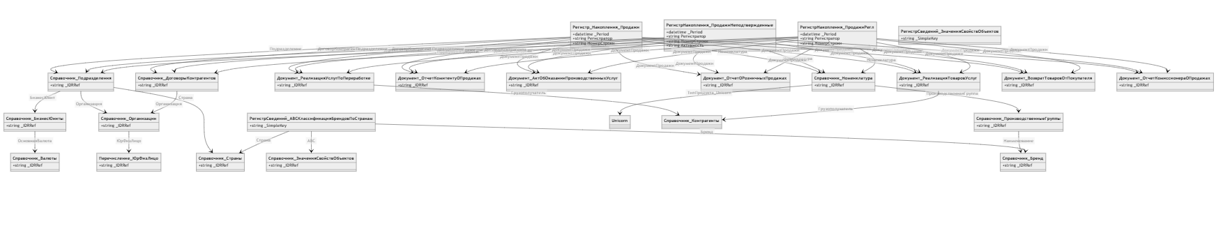
1C Front

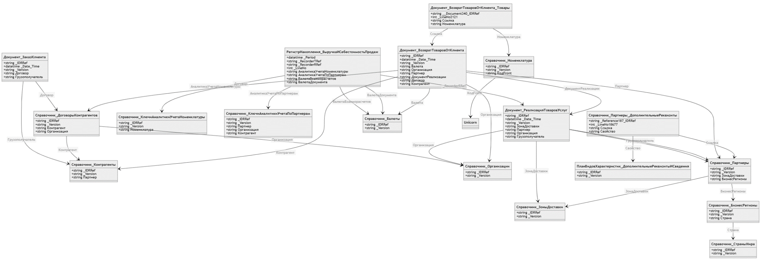
GD Farm
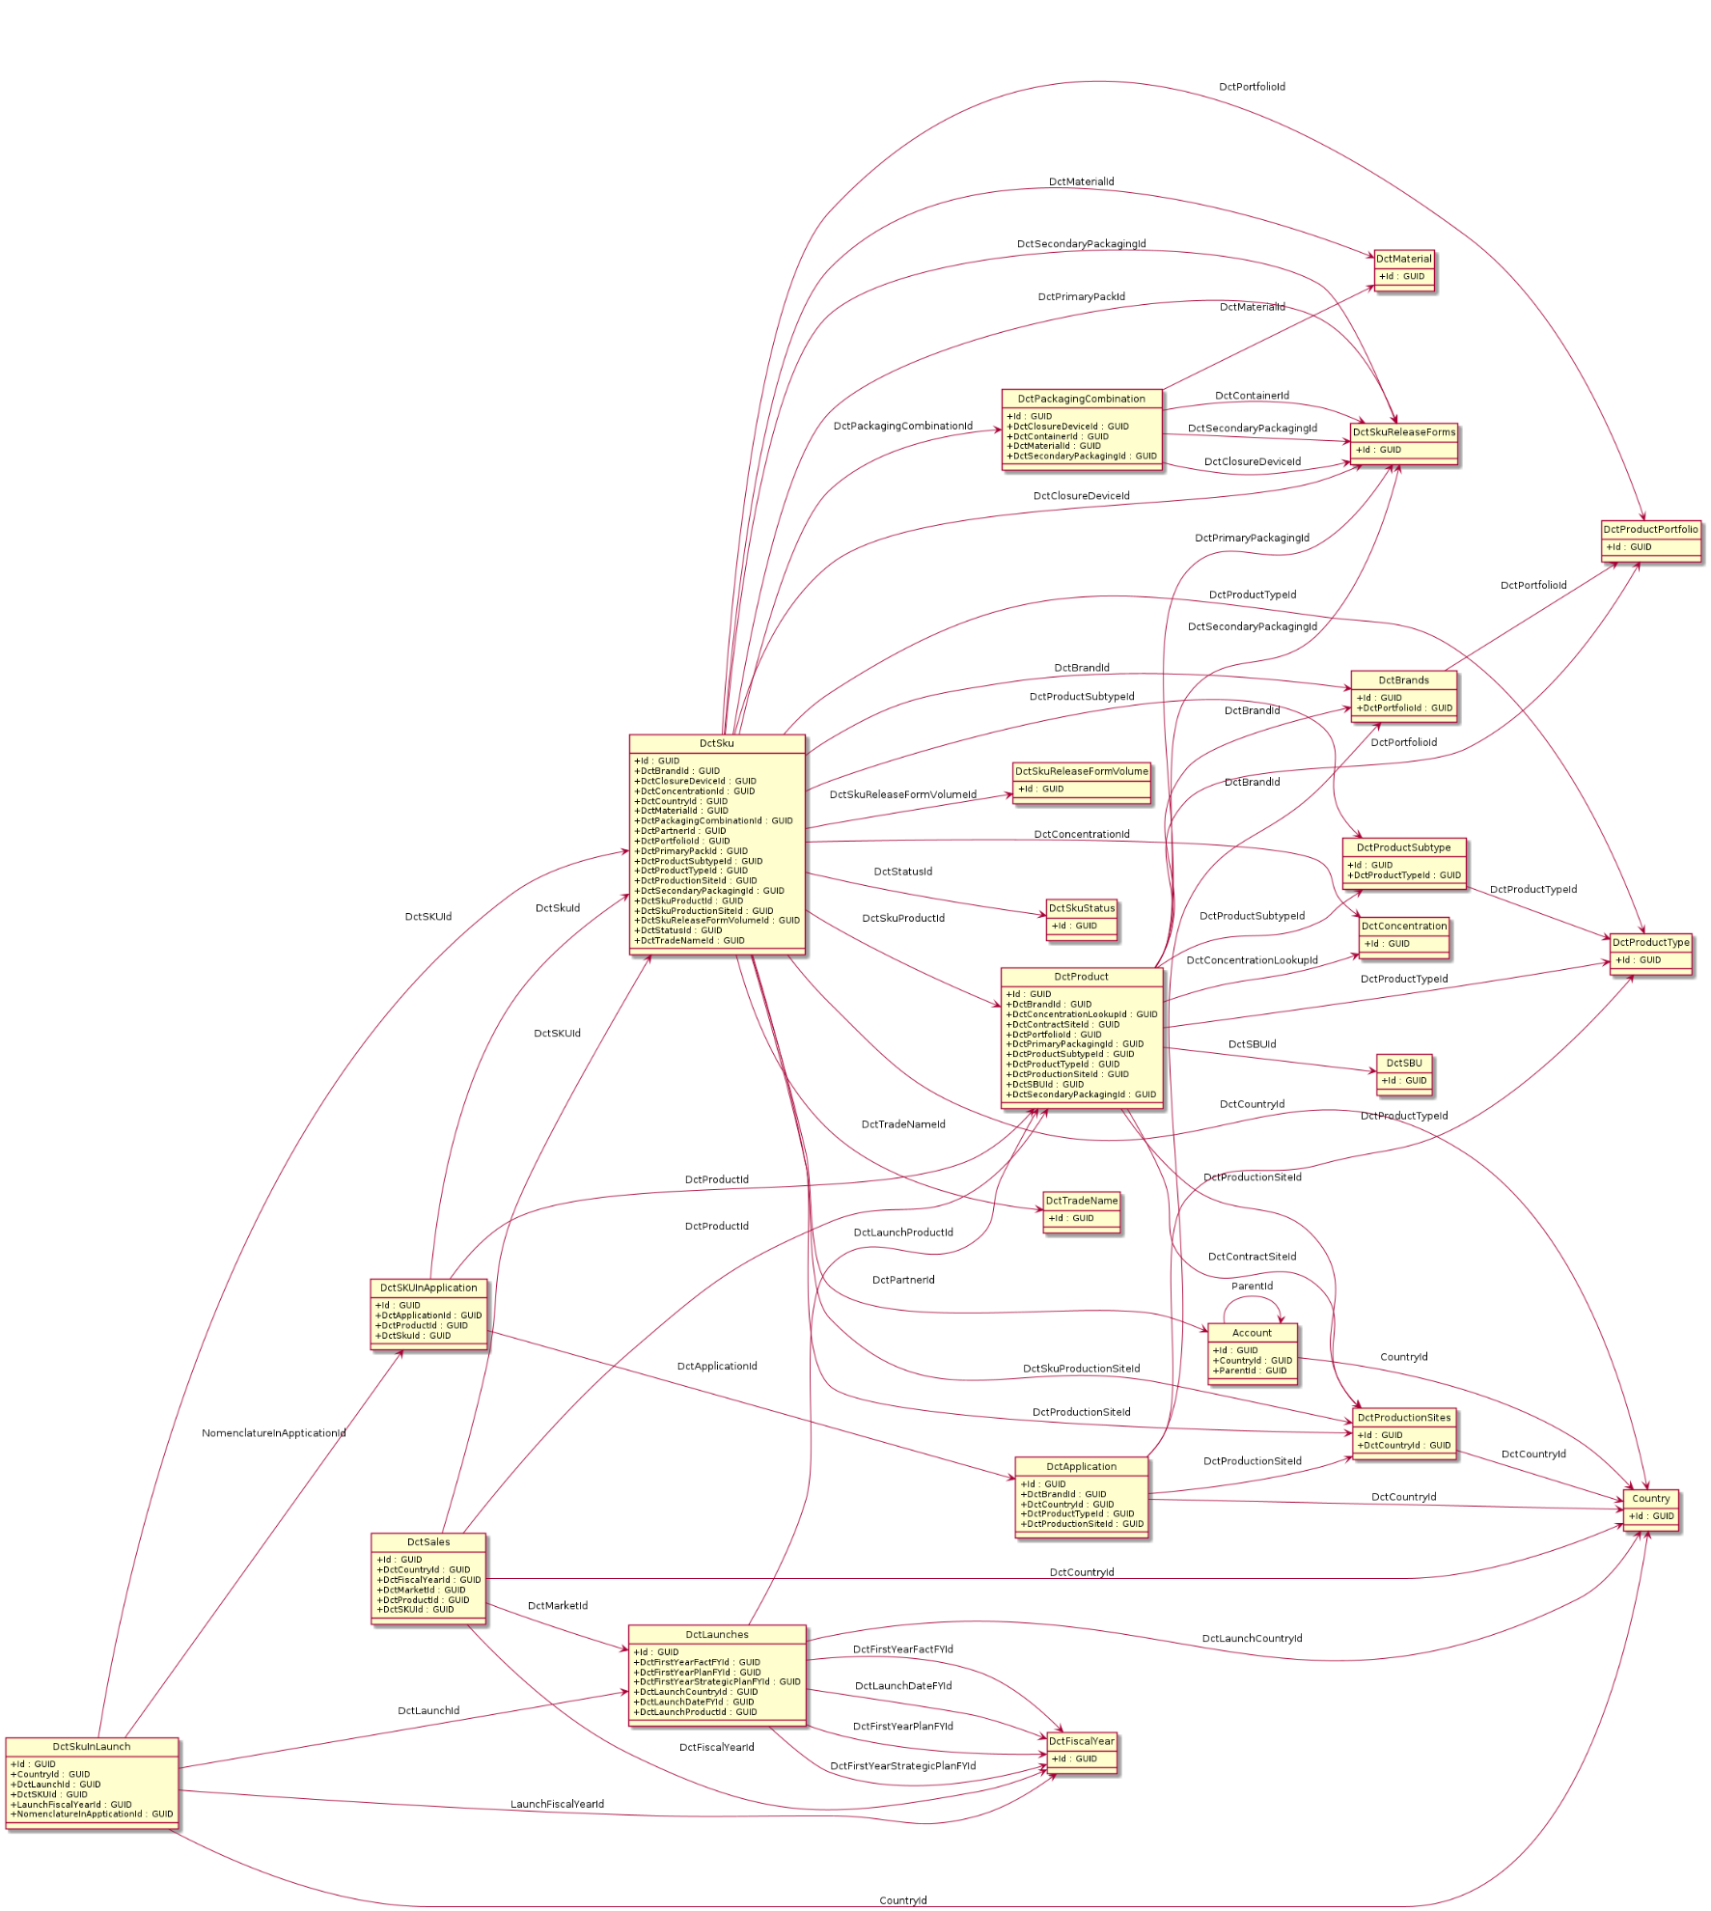
Unicorn

Data migration needs (Assess and document)
The data will be loaded into the DWH from source Systems to the full depth available in those sources

Performance requirements and data transfer requirements
The ETL should process data from 00:00 AM until 08:00 AM every day
Data processing schedule forecast
Data Source | Processing Deadline | Average Processing Time
Raw data | 4:45 AM | 45 min
Dimensions | 5:30 AM | 30 min
Fact tables | 6:00 AM | 30 min
Data marts | 7:00 AM | 30 min
Power BI reports | 8:00 AM | 30 min
Raw data loading forecast
Process | Expected data volume (GB) | Expected processing time for delta (min)
1C Front Load to MS Fabric | 28 | 30 min
Axapta to MS Fabric | 4 | 10 min
Gamma to MS Fabric | 0.01 | 5 min
Unicorn to MS Fabric | 0.01 | 5 min
Morion to MS Fabric | 0.01 | 5 min
GD Pharm to MS Fabric | 0.4 | 5 min
SCM to MS Fabric | 11 | 20 min

Performance and SLA considerations
Performance Metric | Requirement
Response time for 80% of standard queries | Around 20-30 seconds
Impact of ad-hoc queries on solution performance | None (should not affect data processing, refreshes, etc.)

Data upload requirements (Assess and document application)
This section describes the functional requirements for the process of uploading data to the Bronze layer as part of the implementation of the Medallion architecture in Data Lakehouse. The Bronze layer is designed to store raw data received unmodified from various sources in order to ensure its integrity, traceability to the original source, and further processing.
The requirements outlined in this section are intended to ensure reliable, controlled, and scalable data loading in a format that supports further cleansing, transformation, and analytics at the Silver and Gold levels.
The section serves as a basis for developing ETL processes, defining technical and business expectations for processing incoming data, and forms the basis for further quality control and monitoring of the load.

Requirements to control the emergence of new objects or changes in structures
№ | Requirement | Description
1 | Loading all attributes of entities | The Data Warehouse (DWH) must import all attributes of approved entities in accordance with the agreed requirements for each source system. Each table must be loaded in its entirety, including all relevant fields.  Full data loading shall be performed daily with a guarantee of completion by 07:00 Kyiv time (on Gold layer).
2 | Notification of the appearance of a new entity | When a new entity (table or other data object) appears in the source system, responsible persons should automatically receive a notification containing information about the new entity and its affiliation with a particular system.  It should also be possible to fix the list of objects that are present in the source but not yet integrated into DWH.  To do this, the source side must provide access to the full list of entities and their attributes (for example, through information_schema.tables and information_schema.columns in MSSQL).
3 | Notification of adding a new attribute to an existing table | If a new attribute is added to a table integrated in DWH in the source system, the system should: Automatically attempt to update the table structure in DWH using the “schema merge” mechanism in Delta Tables.  Keep a log of such changes. Send notifications to responsible persons about the fact of adding a new attribute.
4 | Notifications about deletion, renaming, or changing the data type of attributes or entities | In case of the following changes in the source system:  - Deleting an entity or attribute  - Renaming an attribute  - Changing the data type of an attribute  the system should automatically generate notifications for responsible persons, indicating the entity, the changed attribute, and the nature of the change. This will allow timely measures to be taken to prevent violations of data integrity and loading processes.

Requirements for the full data download process
№ | Requirement | Description
5 | Full Load of entities | For reference tables and objects for which it is impossible to determine incremental changes, the full load strategy should be used - complete data updates with each import cycle.  In cases where this does not critically affect system performance, it is recommended to switch to incremental data loading as much as possible in order to optimize resources and speed up the update process.

Requirements for the incremental data download process
№ | Requirement | Description
6 | Incremental Load of entities | For all entities, where technically feasible, a strategy should be defined to detect changes (delta) and load only new or updated records to the bronze level.  To support efficient change detection and minimize data movement, a checksum-based delta detection strategy should be implemented where applicable. The source data is logically partitioned into segments (e.g., by business key ranges, or other relevant criteria), and a hash or checksum is computed for each segment. These checksums are then compared against their counterparts in the data warehouse—either by retrieving precomputed values from the source system or by recalculating them from the existing data in the warehouse.  Recalculating checksums within the data warehouse can also serve as a redundancy layer, providing an additional validation step to ensure data consistency and detect discrepancies that may arise due to injection issues.  Segments with mismatched checksums indicate potential changes. Only these segments are extracted and loaded into the staging area for further detailed comparison and processing. This approach significantly reduces the volume of data that must be scanned and transferred, and enables selective updates of only the affected records in the bronze layer.  The incremental loading strategy should be adapted to the specifics of each type of data source, including systems such as MS SQL, PostgreSQL, Microsoft Dynamics AX, REST API, etc.

Requirements for the accumulation of history and the ability to return to a certain state of the object
№ | Requirement | Description
7 | Accumulation of historical data | The system must provide continuous accumulation of change history for all entities at the bronze level. Historical data should be stored for the entire lifetime of the system without deleting or overwriting previous versions.Historization at the bronze layer is intended to enable the transfer of historical information and the extension of the historization process to upper layers when required.  At the silver layer, we implement full-depth historization of the dimensions defined in the table of dimensions above, using SCD Type 2 methodology.  At the gold layer, we primarily retrieve current (actual) data; however, there remains the possibility to elevate specific historical dimensions from the lower layers if needed.
8 | Access to data at a selected point in time | The ability to obtain data in the form in which it existed at a specific point in time may be required for:  - analyzing retrospective changes,  - verification of analytical results  In Delta objects, the default retention period for historical data is 7 days. If necessary, this period can be extended, taking into account the growth of data volume.

Requirements for implementing data quality controls across data layers
As part of the data warehouse (DWH) architecture built on Microsoft Fabric, particular attention is given to the implementation of data quality (DQ) controls across different data processing layers (bronze, silver, gold). The key principles of the Data Quality module design are outlined below:

Layered Approach to Data Quality Checks

The majority of DQ checks are implemented at the silver layer, ensuring that raw, unaltered data remains intact at the bronze layer, closely reflecting the source systems. However, selected validations may also be performed directly at the bronze level, where early detection is required.
Use of Staging Tables
At the bronze layer, staging tables are used primarily for initial data quality validations and for managing the data ingestion process. At the silver and gold layers, staging tables are used more selectively, typically for executing high-priority data validations with corresponded critical tag in DQ configuration.
Use of Alternative Data Quality Validation Methods
- Certain data quality checks may be implemented in the form of constraints at the database level, specifically within the schema definitions of source systems.
- Alternatively, data quality rules can be enforced using custom logic implemented within the DQ module, although this approach is generally more resource-intensive and may require additional development and maintenance effort.
- Where appropriate, validation can also be performed using the capabilities available in Microsoft Fabric, such as dedicated views and reports to identify and monitor data quality issues.
Key Data Quality Control Scenarios
- Composite Key Uniqueness Validation. To ensure data integrity, a uniqueness check can be implemented for a combination of fields across three joined tables from Unicorn source. The validation will be realized as either a view or a physical table, with a separate mechanism configured to validate uniqueness. This approach avoids the need for complex custom validation logic in DQ module.
- Validation for GeneralID in Unicorn. For the DctGeneralId field in the DctSku table within the Unicorn system, a format validation is applied already at the bronze layer. This check ensures that values consist of only Latin letters and digits, and is implemented using regular expressions via the DQ module.
- Monitoring Changes in Record Volume. A mechanism is required to detect anomalous drops or spikes in the number of incoming records. For example, if approximately 100 records are expected daily, but only 2 are received on a given day, the system should trigger an error. This can be implemented by:
  - using a basic genprob DQ module check based on historical (baseline) data patterns;
  - utilizing parameters available in CTL configurations, such as a minimum expected record count;
  - generating a post-factum report to monitor such deviations retrospectively.
- Data Format Validations. To prevent incorrect values (e.g., "1.5 visits"), the following measures are applied:
  - enforcing strict data types at the source system schema level (e.g., using INT instead of VARCHAR);
  - applying regular expression (regex)-based validations via the DQ module when the source schema cannot be modified and the field is of text type. It is also recommended to initiate schema corrections at the source system level to enforce proper data types.

Users and roles (Document user roles, how) + Stakeholder engagement across
# | Role | Description
1 | Project Manager | Oversees project planning, coordination, and execution.
2 | System Analyst | Analyzes and defines high-level system requirements, responsible for system integration and processes in systems (1C, Morion etc)
3 | Technical Analyst | Provides technical system analysis and support.
4 | Business Analyst/Business Consultant | Provides consultations on metric calculation logic and supports understanding of business logic and data indicators.  Advise on the logic of indicator calculations and business processes.
5 | Network Engineer / Infrastructure Director | Responsible for network operations and IT infrastructure management.
6 | Tech Lead | Provides expert support for 1C platform integration, defining basic data rules, requirements, and communication.
7 | Business Sponsors / Stakeholders | Primary business sponsor. Makes final decisions on budget and strategic escalations.

# | Role | Members
1 | Project Manager | O. Malytsia
2 | System Analyst | Danyliuk (GD Pharm), I. Leschenko (CBT), Y.Vasiliev (Front), Iryna.Tokarchuk (Dynamics AX), Antonella Vesnaver (Gamma),  Pavel Sheremet (Morion)
3 | Technical Analyst | Y. Ishсhenko
4 | Business Analyst/Business Consultant | D. Shtepa (Unicorn), A. Vorobiova (Lead Analyst), Y. Bokovenko (Data user from business side)
5 | Tech Lead | O. Levchenko
6 | Network Engineer / Infrastructure Director | O. Iaschenko
7 | Business Sponsors / Stakeholders | T. Stolyar, O. Pyshna
Identify who or what should consume the data
There are three groups of stakeholders for Data Warehouse

Data classification and related risks (Classification and risk of data involved)
Data source | Description | Classification | Risk
1С Front | Includes sales tracking, returns, and financial transactions as well as brands, counterparties, business units, and departments | Restricted | High risk of operational issues if compromised. Risk of privacy breach, non-compliance with data protection laws (e.g. GDPR), reputational damage
GD Pharm | Sales revenue, cost of goods sold, customer returns. Track product catalogs, counterparties, contracts, and business regions | Restricted | High risk of business disruption if compromised. Financial loss, fraud risk, operational disruption, potential legal exposure
SCM | Sales and product distribution planning | Internal Use Only | Moderate risk of operational issues if compromised. Competitive disadvantage if leaked, misalignment in strategic initiatives
Unicorn | Dimension data related to sales. Countries, products, brands, fiscal years, etc. | Confidential | Low risk of operational issues if compromised. Inaccurate reporting, regulatory non-compliance
Morion | Sales documents, products, customers, suppliers, and pricing | Restricted | High risk of business disruption if compromised. Legal and customs compliance issues, liability for third-party assets
Axapta | Customer invoices, inventory transactions and financial transactions | Confidential | Moderate risk of operational issues if compromised. Forecasting errors, supply chain inefficiencies, data inconsistency across systems

Applications infrastructure/networking components (Existing infrastructure/networking)

As-Is Landscape (Current infrastructure or greenfield physical infrastructure) + Identify data sources

Currently, the UF client maintains several on-premises data center (DC) facilities, each with its own isolated network. The UF central facility, located in Ukraine, hosts the existing Data Warehouse (DWH) solution. Access to GD (Uz) is implemented via an MS SQL Linked Server. The Diaco (It) regional office is not integrated into the current DWH solution. The existing network is inaccessible externally and requires a Point-to-Site (P2S) VPN connection from client machines. The DWH virtual machine is configured to access external data sources through the public internet. A Microsoft Power BI on-premises data gateway is configured to facilitate access to analytical data via Microsoft Power BI.

In addition to on-premises infrastructure, the UF client hosts database servers on AWS and utilizes SaaS services accessible through REST APIs. All external data sources require authenticated connections.

The following figure illustrates the UF client's existing network infrastructure.

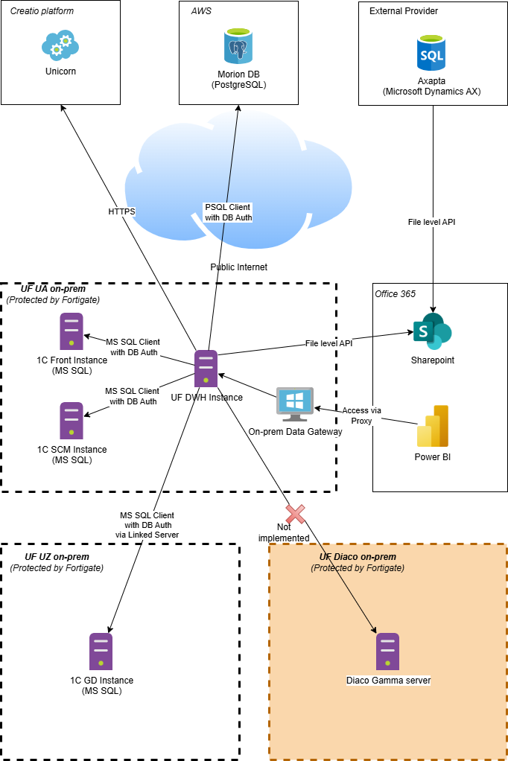

Future Landscape

The Analytics Platform will be hosted and powered by Azure. To establish secure access to the UF client's resources, the following approaches will be employed:

- Communication with on-premises data sources will be established using the Microsoft Fabric VNet Data Gateway and a Site-to-Site VPN connection.
- External data sources hosted on Azure will be accessed through Azure Private Endpoints and Private Links, ensuring that data does not traverse public networks.
- All other external data sources will be accessed via secure SSL connections over the public internet, with access controlled by the authentication layer of each data source.

The following figure illustrates the UF client's future network infrastructure.

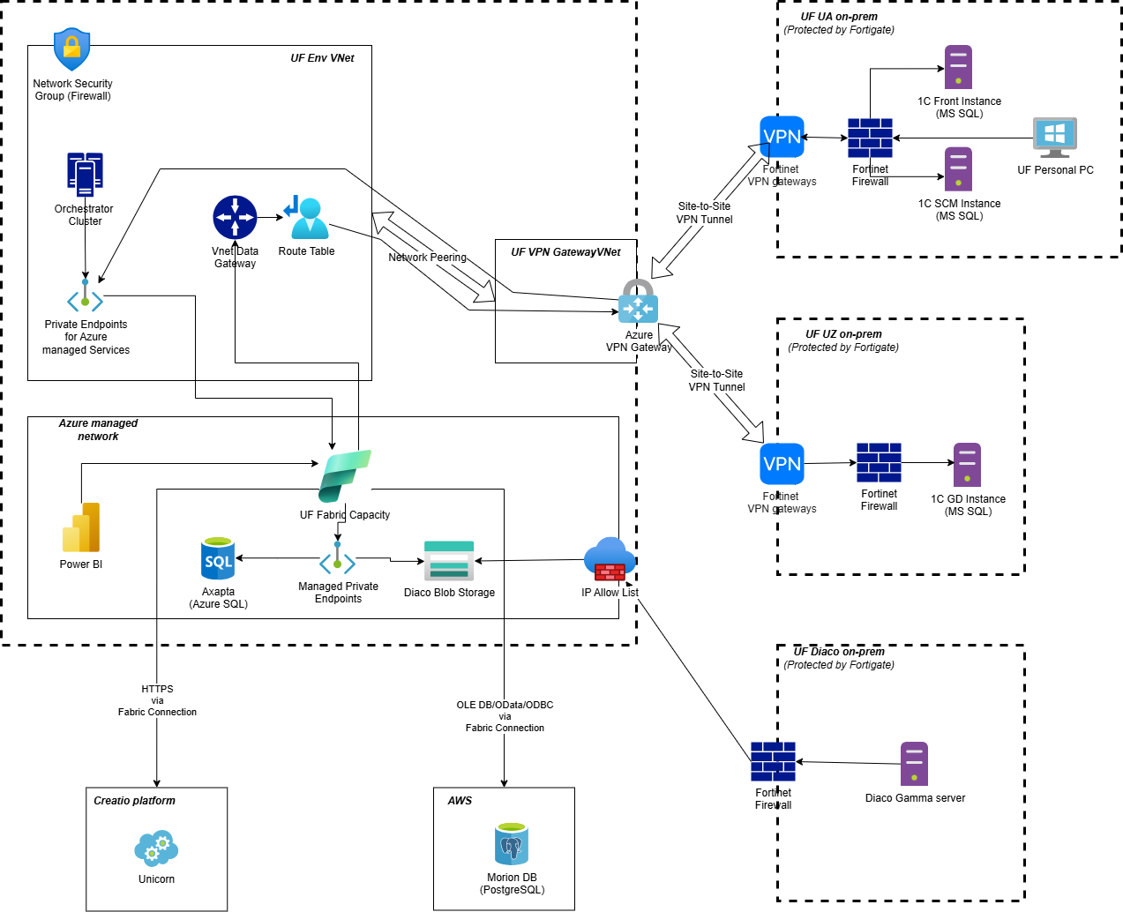

Agreed network diagram with UF CISO
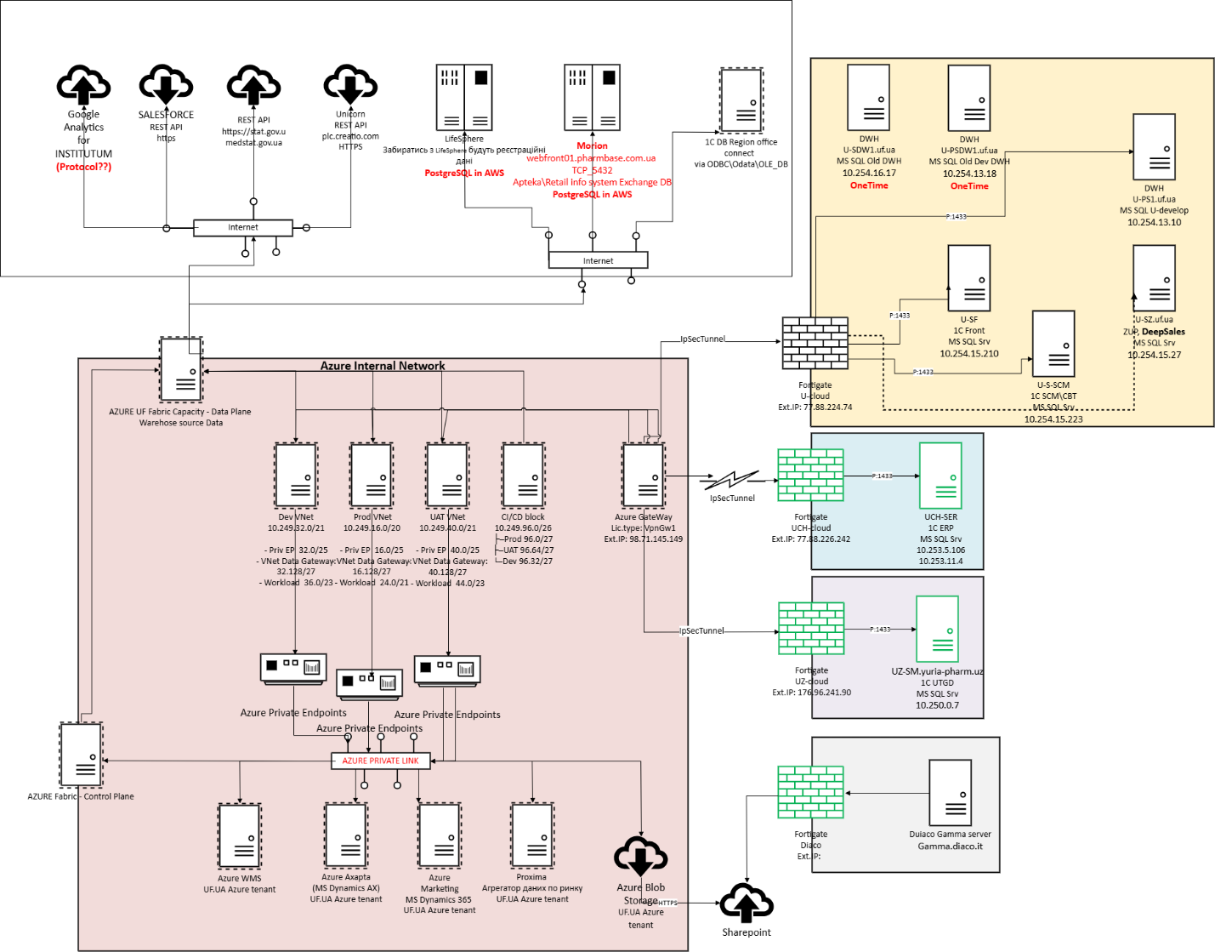

Security and compliance needs (Identity and access management,)
Security Measure | Description
Data Encryption | Implemented encryption at-rest protects collected sensitive data such as 1C data. This ensures that even if unauthorized access occurs, the data remains unreadable and unusable.
Access Control | Access control mechanisms restrict access to the analytical solution and its underlying data. Implemented role-based access control (RBAC) ensures that only authorized personnel have access to specific data and functionalities based on their roles and responsibilities within the company.
Secure Communication | Security protocols (HTTPS) should be employed to encrypt data transmission between different components of the analytical solution, including sources, integration components, data warehouse, analysis tool, and user interfaces. This prevents data tampering during data exchange.
Data Integrity Checks | Implement mechanisms to ensure data integrity through the data processing pipeline.  Filtering of incoming (imported) data  - Validation of attribute types and content according to defined rules  - Additional protection against SQL Injection attacks
Integrating these security measures into the solution allows the company to mitigate security risks, protect valuable data assets, and build trust with stakeholders, thereby enhancing the resilience and reliability of its operations.

Recommended changes and improvements
This document chapter covers the main opportunities and directions where the Kyivstar team sees the most valuable potential for future changes in Yuria-Pharm.
№ | Module/Functional/Process | Description | Recommendations
1 | Infrastructure as Code (IaC) | Automation and disaster recovery foundation. | Using Terraform to describe and deploy the entire DWH infrastructure ensures high availability and rapid recovery in case of incidents. Automating the infrastructure setup allows for repeatability, quick rollback, and scaling, thereby increasing platform resilience and minimizing downtime.
2 | Azure Cloud Data Warehouse | Scalable cloud-based data storage and processing solution. | Unlike on-premise DWHs, Azure offers built-in connectors, seamless updates, a wide marketplace, and high scalability. This managed service supports modern data warehousing needs, including real-time processing and integrations with AI/ML and BI tools.
3 | Naming Convention | Resource naming standards based on Microsoft Cloud Adoption Framework. | A unified naming convention for resources and data objects enhances discoverability, reduces ambiguity, and streamlines research. Though not mandatory, it significantly improves maintainability and clarity across the entire data platform.
4 | ETL/ELT Tool | Visual tool for building and optimizing data transformation workflows. | Enables effective design of ETL/ELT processes and reuse of transformation logic across different workflows. Reduces development time and ensures process consistency while supporting both batch and real-time data flows.
5 | CI/CD Tool | Tool for continuous integration and deployment. | Provides centralized codebase versioning and automates deployments across environments. Ensures consistency and repeatability of releases. Facilitates collaboration by serving as a single source of truth for all developers.
6 | Data Quality Tool | Ensures integrity, completeness, and consistency of data. | Facilitates defining data quality requirements and performing data profiling. Helps maintain trust in the data platform and provides stakeholders with transparent insights into data issues.
7 | Data Flow Management / Orchestration | Centralized control over data pipelines and their execution. | Manages and orchestrates complex data processing workflows with scheduling, triggering, and dependency tracking. Enables recalculations of business periods with ease and ensures consistency and timely delivery of analytical results. Allows switching between automatic and manual flows as per regulations.
These recommended changes and improvements aim to streamline data management processes, enhance data quality and accessibility, and optimize the overall performance of the Yuria-Pharm system. By implementing these enhancements, Yuria-Pharm can leverage its data assets more effectively to drive business growth and innovation.

Resilience, availability, and disaster recovery requirements (Availability, resiliency, and disaster recovery needs:)
The scalability of the solution stands as a one of the key factor motivating the customer's choice to transition to the cloud.
Projected Demand and Scalability: Anticipated demand necessitates the solution's capacity to accommodate peak periods, during which data volume may surge up to 60-75% above the baseline. These peak intervals typically occur at month-end, quarter-end, and year-end. To address these demands, the solution should integrate a monitoring system that alerts when scaling up components becomes necessary. Elastic scaling up and down should be supported by the data warehouse database and ETL components, avoiding re-creations and minimizing downtime. Raw data sourced from the systems should be stored in cost-effective storage, permitting analysis and reprocessing without direct access to the source systems.
Uptime and SLAs: The customer requires the solution to maintain a minimum uptime of 96%, with the data warehouse upholding an SLA of at least 98% during weekdays. Scheduled maintenance should occur from Saturday 4 pm to Sunday 4 pm to mitigate disruptions during operational hours.
Backup and Recovery: Data housed in storage must undergo replication across at least two distinct data centers, while the data warehouse database should enable automatic daily backups. The complete restoration process should not exceed 24 hours.
Conclusion: The customer's expectations regarding scalability, monitoring, backup and recovery, and SLAs within Azure are well-defined. Fulfilling these expectations will be pivotal for the success of the migration initiative. Ensuring scalability, high availability, and resilience against disruptions is paramount, alongside rigorous testing of backup and recovery procedures to swiftly restore data in the event of failures.

Data quality policy and framework establishment ingestion
A Data Quality Policy should be a set of guidelines, that must be followed.
This policy is integrated into the overall Data Governance framework of Yuria-Pharm and aims to:
- Standardize corporate data within the platform based on Microsoft Fabric and medallion architecture.
- Define processes for data validation, cleansing and quality improvement.
- Create a robust data quality monitoring framework to ensure data consistency, uniqueness, correctness, relevance, and completeness.
- Implement clear data quality metrics to continuously monitor, measure, and benchmark data quality performance within the Data Governance Organization.
- Define the structure and processes for timely elimination of data errors (Data Remediation).
Data Quality Management assesses how well data meets the organization's requirements and provides confidence in its accuracy. It helps to meet business needs and optimize the costs associated with maintaining data quality by measuring and monitoring quality levels, analyzing the cost and impact of issues.
All data management processes are aimed at achieving high data quality in accordance with business needs.
Data quality framework high-level view:
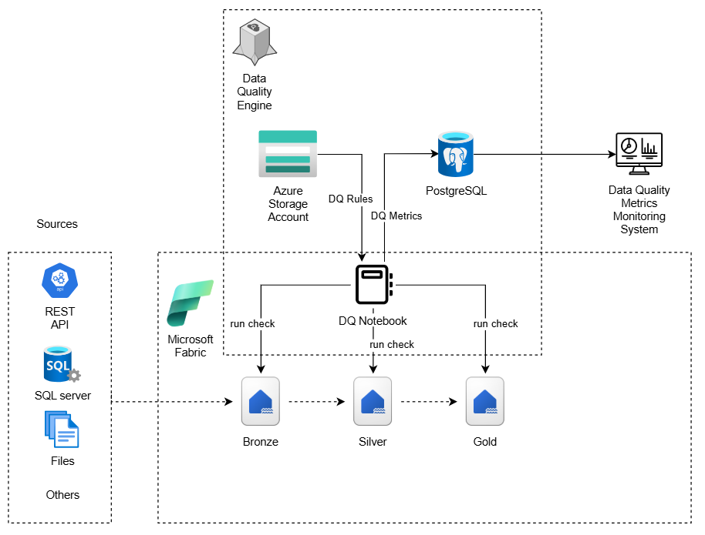
Components of the Data Quality Framework implementation:
- Data Quality Metrics - clear indicators of data quality.
- Data Quality Rules - a set of rules for each metric.
- Data Model - defining models for storing rules, metrics, and errors in Lakehouse (Bronze/Silver/Gold layers) within the medallion architecture.
- Data Validation Pipelines - building data validation pipelines based on Fabric Data Factory / Spark Notebooks / Fabric Pipelines.
The main metrics of data quality:
- Correctness
- Verification of the correctness of filling in the fields.
- Use of both simple rules (checking for null, negative values, valid range) and complex business logic (SQL or Spark queries to Bronze/Silver/Gold layer tables).
- Consistency
- Checks the integrity of foreign keys in fact tables - the presence of corresponding entries in directories.
- Uniqueness
- Checks business keys for uniqueness.
- Search for duplicates in Bronze/Silver/Gold layer data.
Implementation features in Microsoft Fabric:
- Lakehouse is used to store data of different processing levels (Bronze → Silver → Gold).
- Fabric Notebooks or Fabric Pipelines are used to create automated data validation and cleansing processes.

Workflows orchestration
The data quality is closely related to workflows orchestration processes. Such indicators as the timeliness (SLA), consistency, completeness depend on how the source objects were processed. The DWH solution with complex data sources entities dependencies without proper workflows orchestration processes will never be a single source of validated data because of possible data inconsistency. As a part of a problem the failed data processing workflows executions also cause the data quality reducing, which makes a DWH a source of data, which can’t be used as a trusted data source. To solve the described problems a workflows orchestration engine can be used with a data quality engine to increase the data quality and avoid data inconsistency.
The existing client's infrastructure has the various data sources, which include different entities and it's required to implement a workflows orchestration engine to keep DWH data in actual, valid state in accordance with the existing business needs.
The workflows orchestration engine should meet the following requirements:
# | Requirement
1 | To support a SQL Server as a data source to cover the project’s scope
2 | To support a REST API as a data source to cover the project’s scope
3 | To support a Microsoft Dynamics AX as a data source to cover the project’s scope
4 | To support a PostgreSQL as a data source to cover the project’s scope
5 | To support an Azure Storage Account as a data source to cover the project’s scope
6 | To be flexible in data source types extending
7 | To support workflows complex scheduling (hourly/daily/monthly basis)  - Hourly - run workflow every day at specific hours with an ability to specify time and skip some hours (for example - 12:45, 13:45, 14:45 only)  - Daily - run workflow every day once a day at specific hour with an ability to specify time (for example - 03:30 only)  - Monthly - run workflow at specific day of month (for example - 01.01, 01.02, 01.03...01.12)
8 | To support the different data ingestion patterns such as full loading, incremental loading with a minimal configuration
9 | To be flexible in data ingestion patterns extending
10 | To support data sources entities dependencies configuration and tracking
11 | To support workflows executions retries to cover rerun executions strategy
12 | To support storing of historical information about workflows executions, such as execution parameters, workflows executions statuses etc.
13 | To support workflows orchestration metrics monitoring
14 | To support the notifications about failed workflows
15 | To have a UI with an ability to restart failed workflows/workflows activities
16 | To support a Microsoft Fabric as a primary service for data ingestion
17 | To support the calls to Data Quality engine to validate data during ETL/ELT processes
18 | To give an ability to extend data ingestion orchestration with additional steps to refresh Microsoft Power BI reports (not in scope of project, but will be useful in the future)
The following figure demonstrates a future workflows orchestration engine high-level concept:
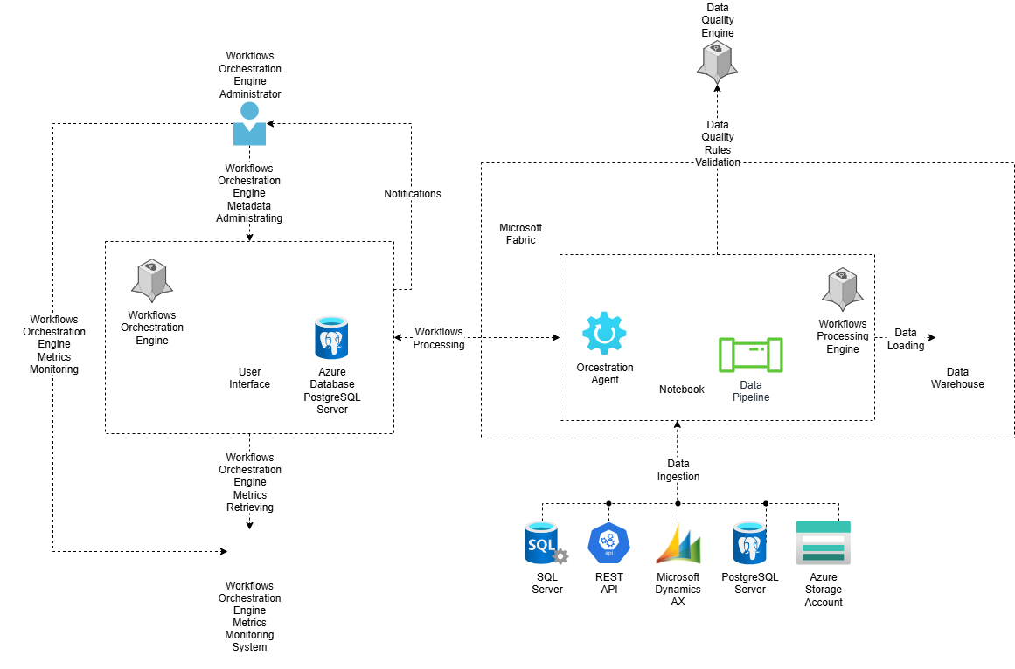
Figure: Workflows orchestration engine concept

Single data repository (Data centralization)
One of the greatest advantages of maintaining a centralized repository is the consolidation of all data sources in a single location. This central hub includes not only data from legacy systems but also any supplementary data. With all data housed in one place, processes like conversion, analytics, and reporting can be executed without affecting existing production systems.
Centralized Repository Advantages | Description
Unified Data Storage | Combines data from various sources, including legacy systems and supplementary data.
Impact-Free Processing | Enables conversion, analytics, and reporting without disrupting production systems.
Historical Data Comparison | Facilitates direct comparison between legacy and post-conversion data at different time points.
Accelerated Validation | Speeds up the validation process by providing all relevant data as it existed at the time of conversion.
By centralizing data at various stages and time points, it becomes feasible to directly compare legacy data with post-conversion data without concerns about data alterations over time. This centralization enhances the validation process by making all necessary data available as it was at the time of conversion.
To support Yuria-Pharm’s long-term data strategy and ensure scalability, flexibility, and governance, Kyivstar proposes to establish a centralized data platform on Microsoft Fabric.
Microsoft Fabric provides a unified data foundation that brings together structured, semi-structured, and unstructured data from various internal and external systems (e.g., 1C, Morion, CBT etc) into a single, governed environment. This platform leverages Lakehouse architecture, which combines the scalability of a data lake with the performance and reliability of a traditional data warehouse.
Key benefits include:
- Single source of truth: all departments operate on the same consistent and verified data.
- Tight integration with Microsoft ecosystem: native connectivity with Power BI, Azure Synapse, Microsoft Purview, and other Microsoft services.
- Scalable and cloud-native: automatically adjusts resources based on workload demands, removing the need for manual infrastructure scaling.
- Supports real-time and batch data processing: enables fast analytics and operational reporting with low-latency data access.
- Improved time-to-insight: through seamless access to curated data and pre-integrated analytical services.
This unified data storage approach helps Yuria-Pharm reduce silos, ensure data quality, and accelerate insights.

Microsoft Fabric Lakehouse concept(Product fit and gaps)
The Microsoft Fabric Lakehouse combines the flexibility and scalability of a traditional Data Lake with the data management features and performance of a Data Warehouse. Built on open standards like Delta Lake and integrated natively within Microsoft Fabric, it enables organizations to ingest, store, transform, and analyze vast volumes of data within a unified platform.
At its core, the Lakehouse in Fabric acts as a centralized data repository that stores raw data in its native format (Bronze layer) and gradually refines it through transformation stages (Silver and Gold layers). This layered Medallion Architecture allows for scalable and traceable data processing, supporting both exploratory data analysis and production-grade business intelligence.
The Lakehouse creates a serving layer by automatically generating a SQL analytics endpoint and a default semantic model during creation. This new see-through functionality allows user to work directly on top of the Delta tables in the lake to provide a frictionless and performant experience all the way from data ingestion to reporting.
It's important to note that the SQL analytics endpoint is a read-only experience and doesn't support the full T-SQL surface area of a transactional data warehouse.
Advantages:
- Unified Storage + Compute: Native support for Spark and SQL workloads in one platform — no need to provision separate services for transformation or analysis
- AI/ML Ready: Centralizing raw and processed data enables easy access for machine learning and Copilot-powered features
- Lower Operational Overhead: Fully managed environment — no manual setup of clusters, metadata stores, or access controls
- Self-Service Friendly: Deep Power BI integration allows business users to explore curated Gold-layer data without needing to know programming languages
- Open Data Format: Supports Delta Lake format, enabling ACID transactions and time-travel queries.
Disadvantages (Compared to Traditional Databases):
- Requires initial transformation of raw enterprise data into lake-compatible formats (e.g., Parquet/Delta)
- Lack of Native Support for Primary and Foreign Keys in Delta Tables
- Full potential is best unlocked by teams familiar with data engineering or scripting tools like SQL or PySpark
These advantages and disadvantages clearly demonstrate the differences between Fabric Lakehouse and traditional databases, which reflect in which cases it is more appropriate to use one or the other technology.
Operational data store + Microsoft Fabric Lakehouse Bronze Layer(Product fit and gaps)

The Bronze Layer in Microsoft Fabric Lakehouse architecture represents an ideal foundation for building an Operational Data Store (ODS). It enables the storage of raw, unprocessed data in a centralized, scalable, and cost-efficient manner — while also supporting both file-based and Delta table formats for flexibility and performance. This layer serves as the ingestion point for all incoming data from various systems such as databases, APIs, or file sources. Data is stored in its original format and structure, with no transformations or business rules applied. Its main function is to provide a single source of truth for downstream processing, analytics, and historical traceability.
Although often described as append-only, the Bronze Layer does support updates and deletions — thanks to Delta Lake capabilities. Rather than overwriting existing data, changes create new versions, preserving historical values and maintaining a complete audit trail. This ensures that original ingested data remains traceable and recoverable over time.

Here's how this combination benefits organizations, along with its pros and cons:
Advantages | Disadvantages
Scalability: Built on OneLake, allows handling large-scale data | No Native PK/FK Constraints: Delta tables do not support primary/foreign keys — integrity must be enforced manually.
Flexible Storage Options: Supports both file-based (CSV, Parquet) and Delta table formats | Requires SQL/Spark/Notebook Skills: Effective use requires knowledge of PySpark and Fabric Notebooks.
Data Versioning & History: Delta format enables time travel and historical tracking of changes | Cloud Dependency: Requires stable internet and reliance on Azure services.
Fabric Ecosystem Integration:Seamless integration with Power BI, Notebooks, Pipelines, and ML features | Maturity of the Platform: As a relatively new service, Microsoft Fabric may introduce changes or limitations as it evolves, which can require adjustments in architecture or workflows
Near Real-Time Ingestion: Supports continuous data ingestion via Fabric Pipelines | -
Implementing an ODS with MS Fabric Lakehouse allows Yuria-Pharm to efficiently leverage raw data for informed decision-making and sustainable business growth. However, it is crucial to balance the advantages with potential limitations and ensure a well-defined strategy for implementation and ongoing management.

BI/ETL software modernization (Product fit and gaps)
The BI/ETL tools usage improves data governance and data processing efficiency with the organization. Such tools help end-users to be more flexible during the development, data analysis and business-decision making processes.
The Yuria-Pharm client already uses a Power BI as a BI tool, which gives an ability to build modern, complex analytical reporting solutions. It can connect to the different data sources with the different data formats and provide the data analysis insights in the different modes (static reports, reports with scheduled refresh, reports with near real-time data).
To modernize the integration part an Microsoft Fabric can be used.
Microsoft Fabric offers an all-in-one data platform that unifies ingestion, transformation, storage, and reporting in a single environment. Fabric natively supports the Lakehouse architecture and the Medallion (Bronze–Silver–Gold) data model, enabling more structured and scalable ETL pipelines. With built-in notebooks for advanced transformations, seamless integration with Power BI, and modern orchestration support, Fabric provides better performance, cost-efficiency, and development agility. As Microsoft's strategic platform for data, it ensures future proofing through continuous innovation and deep ecosystem integration.

ETL on MS Fabric
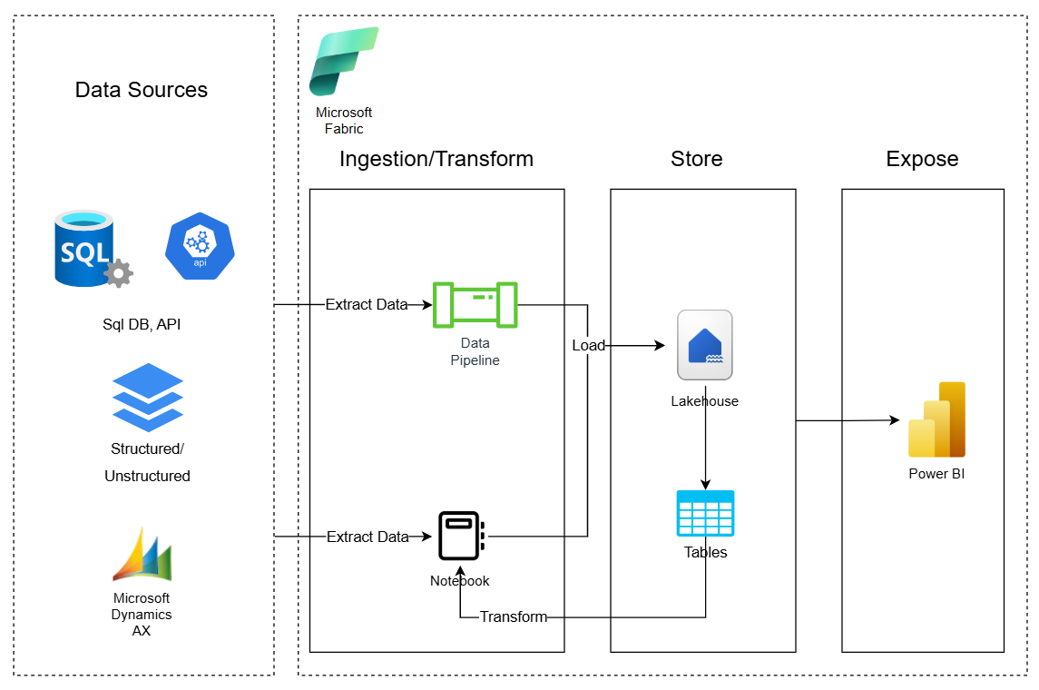

Visual representation of As IS vs future landscape (Data storage needs)

As IS landscape
The company has a data warehouse that is used to generate reports in Power BI. Also, separate showcases are created in the warehouse itself - tables containing certain downloaded and calculated data.
The main reasons for refusing to use the current warehouse are:
- the presence of duplicate data
- insufficient compliance with business requirements (incomplete data)
- complicated logic of data uploading to the storage
The current solution built around MS SQL database hosted on-premises.

As IS landscape

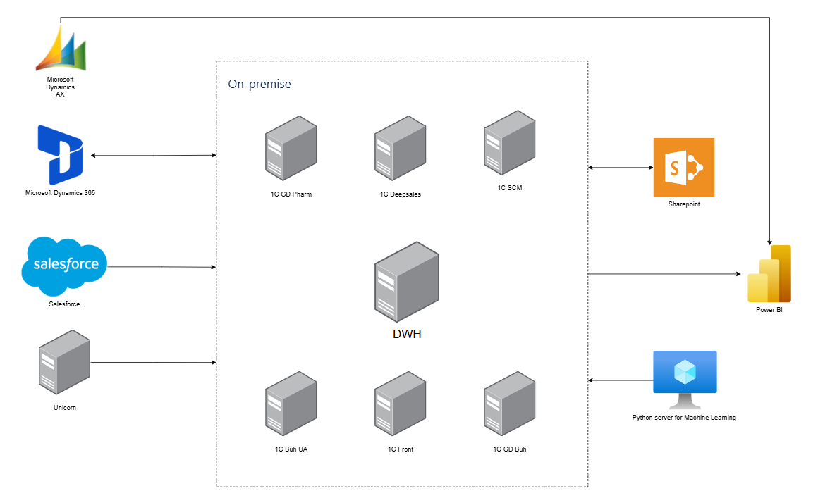
The DWH is the central component that contains all the source data and is located on a separate server. The client already uses Power BI tool to build reporting and visualization. Power BI has access to DWH database server to actualize (refresh) data sources.

Future landscape
The Analytics Platform is a solution designed to enhance quality assurance and improve decision-making processes across the company. It empowers data-driven insights and provides actionable intelligence to maximize productivity.
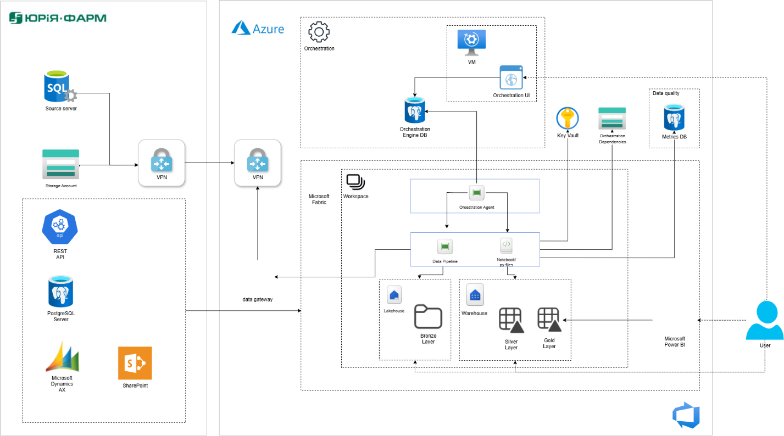

The proposed analytical solution is a cloud-native implementation built on Microsoft Fabric, leveraging the Medallion Architecture to ensure structured data processing and scalable analytics. This architecture organizes data into three logical layers—Bronze, Silver, and Gold—to streamline ingestion, transformation, and consumption of high-quality, reliable data.
The solution consists of the following key components:
- Data Ingestion Layer (Bronze): Responsible for collecting and ingesting raw data from multiple heterogeneous sources, including financial systems. Data is landed in its original format for traceability and audit purposes
- Storage and Transformation Layer (Silver): Provides scalable and secure data storage while cleaning, filtering, and transforming raw data into a structured and enriched format suitable for analytical processing
- Analytical Engine (Gold): Performs advanced aggregations, business logic application, and joins across domains to produce high-value, curated datasets optimized for reporting and decision-making
- Visualization Layer: Delivers actionable insights through interactive dashboards, rich visualizations, and self-service analytics tools to empower users across the organization
By adopting Microsoft Fabric, the platform benefits from native integration with Azure services, reuse of existing SQL/MSSQL expertise, and enhanced scalability, performance, and cost-efficiency for enterprise-level analytics.

The solution comprises the following core components:
- Data Ingestion Services: Built using Azure Fabric Pipelines and Notebooks, enabling flexible and scalable data integration workflows
- SQL-Based Data Extraction: Data from operational SQL databases (e.g., 1C) is extracted using Pipelines and loaded into the Microsoft Fabric Lakehouse at the Bronze layer for raw data storage
- API Integration (e.g., Unicorn): REST API data is ingested using Pipelines and Notebooks, which orchestrate logic to interact with external APIs and persist the results in the Lakehouse
- Lakehouse Architecture: Serves as the central repository for all raw ingested data (Bronze layer), providing unified, scalable storage optimized for analytical workloads
- Data Transformation & Analytics Engine: Azure Fabric Notebooks are used for data cleansing, transformation (Silver layer), and advanced analytics (Gold layer), supporting business-ready datasets
- Workflow Orchestration: Orchestration Agent implemented by Microsoft Fabric Data Pipelines coordinates ETL processes, leveraging metadata stored in an Azure PostgreSQL database to manage task dependencies and execution logic
- Data Quality Framework: Implemented using Microsoft Fabric Notebooks, with quality metrics and validation rules. Logging and validation metrics are stored in a special schema in the Azure PostgreSQL metadata store
- Security and Secrets Management: Azure Key Vault is integrated across all critical services to securely manage sensitive information, monitor usage, and audit access
- Reporting and Visualization: Power BI is used to deliver interactive dashboards and reports, providing actionable insights for business stakeholders

Skilling plan
This skilling plan defines the key technical competencies required for the UF team to successfully adopt and operate the Microsoft Fabric-based data warehouse and analytics platform. It aligns required capabilities with the identified user roles and ensures readiness across data engineering and reporting functions.

Skill Area | Target Roles | Current Level | Training
Fabric Warehouse & Medallion Architecture | Data Analyst, Data Engineer | None | Learning session + MS Learn guided modules
Data Ingestion & Pipeline Development | Data Engineer | None | Learning session + MS Learn guided modules
Notebook Development (Python, PySpark) | Data Engineer | Basic | Project-based exercises
SQL-Based Data Transformation & Optimization | Data Analyst, Data Engineer | Intermediate | Guided project exercises + reference documentation
Azure DevOps & Source Control (Git, CI/CD) | All technical roles | Basic | Practical Git/DevOps exercises using project components + reference documentation
Data Quality Framework | Data Engineer | None | Learning session + reference documentation
Workflow Orchestration & Monitoring | Data Engineer, Tech Lead | None | Learning session + reference documentation
Fabric Workspace Management | Tech Lead, Data Engineer | None | Learning session on Fabric workspace structure + how-to guides
Power BI Reporting | Data Analyst | Intermediate | Project-based exercises
Azure Resource Management & Security | Tech Lead, Data Engineer | Basic | Learning session + hands-on Azure Portal exercises
Knowledge transfer will be integrated as a structured enablement phase toward the end of the implementation to ensure operational readiness of the Microsoft Fabric-based platform. The approach includes comprehensive how-to and architectural documentation, instructor-led learning sessions covering Fabric architecture and workspace structure, guided walkthroughs of the implemented Warehouse solution, and practical exercises using real project components.
Skilling success is measured by the UF team’s ability to independently operate and extend the solution. Data Engineers independently develop and maintain Fabric Pipelines and Notebooks supporting Bronze/Silver/Gold transformations and data quality checks, while Data Analysts create governed Power BI reports. The team effectively uses Azure DevOps for source control and deployment, and achieves operational self-sufficiency.

Implementation roadmap
Based on the project business goals, we recommend to implement solution within following phases
Phase | Service Description | Start Date | End Date | Work Results
Phase 1. Requirements Analysis and Basic Infrastructure Deployment in Dev Environment | 1.1 Analysis of current state and business requirements  1.2 Analysis and documentation of KPIs, loading strategy, and data sources information  1.3 Analysis of requirements for templates for loading data to the Bronze level  1.4 Deployment of basic Azure components in the development environment  1.5 Setting up connectivity between development environment and data source systems | 07.04.2025 | 30.04.2025 | 1.1 Document with analysis of current state and requirements  1.2 Documented KPIs  1.3 Document with requirements for Bronze level templates  1.4 Deployed basic infrastructure for the development environment  1.5 Configured network and connectivity to data sources
Phase 2. Formation of Orchestration/Data Quality Requirements. Development of Bronze Level Loading Templates | 2.1 Description of requirements for orchestration and data quality  2.2 Deployment of infrastructure for the development environment components  2.3 Development of Bronze level loading templates  2.4 Loading data to the Bronze level (required for KPI calculation) | 01.05.2025 | 30.05.2025 | 2.1 Requirements described  2.2 Infrastructure deployed  2.3 Templates developed  2.4 Data loaded
Phase 3. Data Quality and Notification Module Requirements. Development of Silver Level Loading Templates | 3.1 Description of notification module requirements  3.2 Development of Silver level loading templates  3.3 Documentation of templates  3.4 Data model development | 02.06.2025 | 30.06.2025 | 3.1 Notification module requirements described  3.2 Templates for Silver level developed  3.3 Templates documented  3.4 Data model developed
Phase 4. Development of Orchestration and Data Quality Modules | 4.1 Development of the orchestration module  4.2 Development of the data quality module  4.3 Description of requirements for historical data loading | 01.07.2025 | 31.07.2025 | 4.1 Orchestration module developed  4.2 Data quality module developed  4.3 Requirements for historical data loading described
Phase 5. Data Loading to Silver Level and Historical Data Loading | 5.1 Development of data loading processes to the Silver level  5.2 Loading historical data | 01.08.2025 | 29.08.2025 | 5.1 Data loading processes developed  5.2 Historical data loaded
Phase 6. KPI Calculation at the Gold Level and Notification Module Setup. CI/CD Implementation | 6.1 Loading data to the Gold level  6.2 CI/CD setup and deployment of production environment  6.3 Notification module configuration  6.4 Preparation of documentation: administrator guide and general system documentation | 01.09.2025 | 30.09.2025 | 6.1 Data loaded to Gold level  6.2 CI/CD built and production environment deployed  6.3 Notification module configured  6.4 Documentation prepared
Phases 1,2 – Implements MVP with the ETL/ELT processes for downloading data to Bronze level of DWH Fabric
Phases 3,4,5,6– Implements the DWH development for all Data Sources on Bronze, Silver, Gold levels including data quality and workflows orchestration engines implementation.

Assumptions and limitations
This section summarizes main assumptions and limitations based on which solution vision and scope is designed and described in this document.
ASSUMP-ID | Name | Description
ASSUMP-01 | Data quality | Data quality rules and their priorities should be defined and approved by data owners
ASSUMP-02 | Workflows schedules | Data processing workflows schedules should be defined and approved by data owners
ASSUMP-03 | Workflows Dependencies | Data processing workflows dependencies should be defined and approved by data owners
ASSUMP-04 | DWH implementation | The DWH implementation should be split into different phases in accordance with business prioritization
ASSUMP-05 | Data sources ingestion implementation priority | The first phase of the data sources ingestion implementation should include 1C Front, Gamma, GD Pharm, Microsoft Dynamics AX, Unicorn, SCM, Morion  data sources only
ASSUMP-06 | Loading of 1C (SQL Server) heavy objects | Some of the 1C (SQL Servers) objects contain large volumes of data and currently support only a full-load pattern. The client should revise and optimize the loading strategy for these objects before ingestion implementation.
ASSUMP-07 | Notifications templates | Workflows orchestrations notifications templates should be defined and approved by data owners for every separate case before implementation
ASSUMP-08 | Workflows compute engine | The workflows compute engine should be built using the Microsoft Fabric, if possible

Budget (Budget)
Dedicated Team engagement model with Fix Price billing Model
Role | Description | FTE
Project Manager | Responsible for overall project management, planning, monitoring, and client communication. | 1
Solution/Data Architect | Designs the DWH architecture, ensures proper data integration, and selects optimal solutions. | 2
Data Analyst | Analyzes data, defines business requirements, and creates data models for the data warehouse. | 2
Data Engineer | Implements ETL processes, responsible for data migration, transformation, and integration. | 6
DevOps | Ensures stable infrastructure operation, deployment automation, and system monitoring. | 1
QA | Performs data warehouse testing, checks data quality and solution compliance with requirements. | 1
Payments under this project are made according to the progress of completed work and the rates defined in the contract.
Planned Azure consumption:
Environment | Calculation
DEV/TEST | https://azure.com/e/01128beb809f471ca189b6fc05bc1002/
PROD | https://azure.com/e/0cfb5882a1854be297a613f52c6839dd/
PROD (with reservation) | https://azure.com/e/e042d43d84b240c3948969ff45814771/

Annexes

Annex 1. Data models

SCM

Organizational Structure:

select bu._Description as BusinessUnit_Name,
trim(bu._code) as BusinessUnit_Code,
bu._IDRRef as BusinessUnit_UUID,
cu._Description as CountryUnit_Name,
trim(cu._code) as CountryUnit_Code,
cu._IDRRef as CountryUnit_UUID,
co._fld371 as Country_Alfa3Code,
co._Description as Country_Name,
trim(co._code) as Country_Code,
co._IDRRef as Country_UUID,
r._Description as Region_Name,
trim(r._code) as Region_Code,
r._IDRRef as Region_UUID,
p._Description as Place_Name,
trim(p._code) as Place_Code,
p._IDRref as Place_UUID,
wrh._Description as Warehouse_Name,
wrh._code as Warehouse_code,
wrh._Fld371 as [Warehouse code to Link to 1C],
wr_acc._Description as Ur_osoba,
wr_acc._Code as Ur_osoba_Code
from ( select mb._IDRRef, mb._Description, mb._code
from scm_dwh.dbo._Reference37 mb
inner join scm_dwh.dbo._Reference55 r on r._idrref = mb._Fld368RRef
where r._description = 'Business Unit'
) as bu
-- country unit
left join ( select rg._fld2207rref, mb._IDRRef, mb._Description, mb._code
from scm_dwh.dbo._InfoRg2204 rg
inner join scm_dwh.dbo._Reference37 mb on mb._idrref = rg._fld2205rref
inner join scm_dwh.dbo._Reference55 r on r._idrref = mb._Fld368RRef
where r._description = 'Country Unit'
) as cu on cu._fld2207rref = bu._IDRRef
-- country
left join scm_dwh.dbo._InfoRg2204 ir_co on ir_co._fld2205rref = cu._IDRRef and EXISTS (select * from scm_dwh.dbo._Reference55 as r55 where r55._description = 'Country' and r55._idrref = ir_co._fld2206rref)
left join (select mb._IDRRef, mb._Description, mb._code, mb._fld371
from scm_dwh.dbo._Reference37 mb
inner join scm_dwh.dbo._Reference55 r on r._idrref = mb._Fld368RRef
where r._description = 'Country'
) co on co._IDRRef = ir_co._fld2207rref
-- regions
left join ( select rg._fld2207rref, mb._IDRRef, mb._Description, mb._code
from scm_dwh.dbo._InfoRg2204 rg
inner join scm_dwh.dbo._Reference37 mb on mb._idrref = rg._fld2205rref
inner join scm_dwh.dbo._Reference55 r on r._idrref = mb._Fld368RRef
where r._description = 'Regions'
) as r on r._fld2207rref = cu._IDRRef
-- places
left join ( select rg._fld2207rref, rg._fld2206rref, mb._IDRRef, mb._Description, mb._code
from scm_dwh.dbo._InfoRg2204 rg
inner join scm_dwh.dbo._Reference37 mb on mb._idrref = rg._fld2205rref
inner join scm_dwh.dbo._Reference55 r on r._idrref = mb._Fld368RRef
where r._description = 'Places'
) as p on p._fld2207rref = r._IDRRef
-- warehouses
left join (
select
mb._idrref as Place_UUID
,wp._code
,wp._Description
,wp._Fld371
,wp._idrref
from scm_dwh.dbo._InfoRg2204 rg
inner join scm_dwh.dbo._Reference37 mb on mb._idrref = rg._fld2205rref --
inner join _Reference37 wp on wp._idrref = rg._fld2207rref --Справочник.ЦБТ_СубъектыПланирования
inner join _Reference55 wpm1 on wpm1._idrref = rg._fld2206rref
and wpm1._Description = 'Склад'
) wrh on wrh.Place_UUID = p._IDRRef
-- warehouses owners
left join (
select
mb._idrref as WareHouse_UUID
,wp._code
,wp._Description
from scm_dwh.dbo._InfoRg2204 rg
inner join scm_dwh.dbo._Reference37 mb on mb._idrref = rg._fld2205rref --
inner join _Reference37 wp on wp._idrref = rg._fld2207rref --Справочник.ЦБТ_СубъектыПланирования
inner join _Reference55 wpm1 on wpm1._idrref = rg._fld2206rref
and wpm1._Description = 'Юридическое лицо Склад'
) wr_acc on wr_acc.WareHouse_UUID = wrh._IDRRef

Data Model Implemented in SQL

with cte as(
select bu._Description as BusinessUnit_Name,
trim(bu._code) as BusinessUnit_Code,
bu._IDRRef as BusinessUnit_UUID,
cu._Description as CountryUnit_Name,
trim(cu._code) as CountryUnit_Code,
cu._IDRRef as CountryUnit_UUID,
co._fld371 as Country_Alfa3Code,
co._Description as Country_Name,
trim(co._code) as Country_Code,
co._IDRRef as Country_UUID,
r._Description as Region_Name,
trim(r._code) as Region_Code,
r._IDRRef as Region_UUID,
p._Description as Place_Name,
trim(p._code) as Place_Code,
p._IDRref as Place_UUID,
wrh._Description as Warehouse_Name,
wrh._code as Warehouse_code,
wrh._Fld371 as [Warehouse code to Link to 1C],
wr_acc._Description as Ur_osoba,
wr_acc._Code as Ur_osoba_Code
from ( select mb._IDRRef, mb._Description, mb._code
from scm_dwh.dbo._Reference37 mb
inner join scm_dwh.dbo._Reference55 r on r._idrref = mb._Fld368RRef
where r._description = 'Business Unit'
) as bu
-- country unit
left join ( select rg._fld2207rref, mb._IDRRef, mb._Description, mb._code
from scm_dwh.dbo._InfoRg2204 rg
inner join scm_dwh.dbo._Reference37 mb on mb._idrref = rg._fld2205rref
inner join scm_dwh.dbo._Reference55 r on r._idrref = mb._Fld368RRef
where r._description = 'Country Unit'
) as cu on cu._fld2207rref = bu._IDRRef
-- country
left join scm_dwh.dbo._InfoRg2204 ir_co on ir_co._fld2205rref = cu._IDRRef and EXISTS (select * from scm_dwh.dbo._Reference55 as r55 where r55._description = 'Country' and r55._idrref = ir_co._fld2206rref)
left join (select mb._IDRRef, mb._Description, mb._code, mb._fld371
from scm_dwh.dbo._Reference37 mb
inner join scm_dwh.dbo._Reference55 r on r._idrref = mb._Fld368RRef
where r._description = 'Country'
) co on co._IDRRef = ir_co._fld2207rref
-- regions
left join ( select rg._fld2207rref, mb._IDRRef, mb._Description, mb._code
from scm_dwh.dbo._InfoRg2204 rg
inner join scm_dwh.dbo._Reference37 mb on mb._idrref = rg._fld2205rref
inner join scm_dwh.dbo._Reference55 r on r._idrref = mb._Fld368RRef
where r._description = 'Regions'
) as r on r._fld2207rref = cu._IDRRef
-- places
left join ( select rg._fld2207rref, rg._fld2206rref, mb._IDRRef, mb._Description, mb._code
from scm_dwh.dbo._InfoRg2204 rg
inner join scm_dwh.dbo._Reference37 mb on mb._idrref = rg._fld2205rref
inner join scm_dwh.dbo._Reference55 r on r._idrref = mb._Fld368RRef
where r._description = 'Places'
) as p on p._fld2207rref = r._IDRRef
left join (
select
mb._idrref as Place_UUID
,wp._code
,wp._Description
,wp._Fld371
,wp._idrref
from scm_dwh.dbo._InfoRg2204 rg
inner join scm_dwh.dbo._Reference37 mb on mb._idrref = rg._fld2205rref --
inner join _Reference37 wp on wp._idrref = rg._fld2207rref --Справочник.ЦБТ_СубъектыПланирования
inner join _Reference55 wpm1 on wpm1._idrref = rg._fld2206rref
and wpm1._Description = 'Склад'
) wrh on wrh.Place_UUID = p._IDRRef
left join (
select
mb._idrref as WareHouse_UUID
,wp._code
,wp._Description
from scm_dwh.dbo._InfoRg2204 rg
inner join scm_dwh.dbo._Reference37 mb on mb._idrref = rg._fld2205rref --
inner join _Reference37 wp on wp._idrref = rg._fld2207rref --Справочник.ЦБТ_СубъектыПланирования
inner join _Reference55 wpm1 on wpm1._idrref = rg._fld2206rref
and wpm1._Description = 'Юридическое лицо Склад'
) wr_acc on wr_acc.WareHouse_UUID = wrh._IDRRef
)
select
--r._Description,
--mb._Description,
--d.*
--_Reference53.*
t._Number,
pl._Description as PlanningType,
--r._Description,
--r._Fld9851RRef,
st._Description as SourceOfFin,
mb1._Description as SKU_Name,
mb1._Fld6380 as SKU_GUID,
-- prop._IDRRef as OrgTypeId,
prop._Description as OrgType,
-- spl._IDRRef as OrgId,
spl._Description as OrgName,
cte.BusinessUnit_Name as BU,
cte.Country_name as [Country of Sale],
coalesce(cte.place_name, cte.region_name, cte.CountryUnit_Name) as Region,
coalesce(cte.Ur_osoba, 'N/A') as Ur_osoba
from
_Document99 t
inner join _Document99_VT2003 d on d._Document99_IDRRef=t._IDRRef
inner join _Reference12 pl on pl._IDRRef = t._Fld1997RRef
inner join _Reference36 st on st._IDRRef = t._Fld2000RRef
--inner join _Reference54 r on r._IDRRef=t._Fld4902RRef --Справочник.ЦБТ_СвойстваОбъектовПланирования ??? Left join increasing num of records
left join _Reference53 mb1 on mb1._IDRRef = d._Fld2007RRef
left join _Reference55 prop on prop._IDRRef = t._Fld4904RRef
left join _Reference37 spl on spl._IDRRef = d._Fld2006RRef
left join cte on COALESCE(cte.Place_UUID, cte.Region_UUID, cte.CountryUnit_UUID, cte.Country_name) = spl._IDRRef
where 1=1
and cast(t._Posted as int) = 1 --only posted documents
and t._Number in (000000003,000199690)
order by 1 desc

Data Model Dimension Logic

Dimension Name | Value | Target Table
Legal Entity | МТК | select  mb._idrref as WareHouse_UUID ,wp._code as Ur_osoba_code ,wp._Description as Ur_Osoba  from scm_dwh.dbo._InfoRg2204 rg  inner join scm_dwh.dbo._Reference37 mb on mb._idrref = rg._fld2205rref  inner join _Reference37 wp on wp._idrref = rg._fld2207rref  inner join _Reference55 wpm1 on wpm1._idrref = rg._fld2206rref  and wpm1._Description = 'Юридическое лицо Склад'
Country of Sale | Kyrgyzstan | select mb._IDRRef, mb._Description as Country, mb._code as Country_Code, mb._fld371  from scm_dwh.dbo._Reference37 mb  inner join scm_dwh.dbo._Reference55 r on r._idrref = mb._Fld368RRef  where r._description = 'Country'
Regional Division | Чернівці | select rg._fld2207rref, mb._IDRRef, mb._Description as Region, mb._code as Region_Code  from scm_dwh.dbo._InfoRg2204 rg  inner join scm_dwh.dbo._Reference37 mb on mb._idrref = rg._fld2205rref  inner join scm_dwh.dbo._Reference55 r on r._idrref = mb._Fld368RRef  where r._description = 'Regions'
Product | SKU Name: Декасан® р-н 1000мл (ПВХ-контейнер)  SKU_GUID: e302c87e-d142-11db-893e-505054503030 | select mb1._Description as SKU_Name, mb1._Fld6380 as SKU_GUID  from _Document99_VT2003 d  left join _Reference53 mb1 on mb1._IDRRef = d._Fld2007RRef
Period | 2022-07-01 00:00:00.000 | select coalesce(d._Fld4905, h._Fld1995) as Month_Plan  from _Document99 h  inner join _Document99_VT2003 d on d._Document99_IDRRef=h._IDRRef
Finished Product Nomenclature | SKU_GUID → Unicorn.dctsku.Dct1CIntegrationId | Link to Unicorn by SKU GUID to grab Product Info
Source of Funding | 1 Заказан в финансовой системе  45 Заказан в финансовой системе. FMCG  44 Заказан в финансовой системе. Бюджет | select st._Description as SourceOfFin  from _Document99 t  inner join _Reference36 st on st._IDRRef = t._Fld2000RRef
Business Unit | Health EEMA | select mb._IDRRef, mb._Description as BU, mb._code as BU_Code  from scm_dwh.dbo._Reference37 mb  inner join scm_dwh.dbo._Reference55 r on r._idrref = mb._Fld368RRef  where r._description = 'Business Unit'
ABC Sales Categorization

Axapta

Data model:

select
j.InvoiceAccount
, j.InvoiceAccountGUID
, j.InvoiceId
, j.InvoiceDate
, j.InvoiceAmount
, citbe.SalesId
, citbe.Qty
, citbe.ItemId
, citbe.Qty
, ct.InvoiceTransRecId
, ct.InventTransId
, ct.ItemGUID
, ct.ItemId
, ct.Amount
, ct.VATAmount
, ct.VATValue
, ct.Qty
, ct.UnitId
, cbe.SalesDistrictId as oblast
, so.PoolName
, j.Currency
, cbe.Party
, ct.LocationId
, citbe.DeliveryPostalAddress
, j.DeliveryAddress
, co.Name as UrOsoba
--, ptbi.Name as AccName
, pa.CountryRegionId
from [ax_undefined].[custinvoicejouryp] j
inner join [ax_undefined].[custinvoicetransbientities] citbe on j.InvoiceId = citbe.InvoiceId
inner join [ax_undefined].[custinvoicetransyp] ct on ct.InventTransId = citbe.InventTransId
inner join [ax_undefined].[custtablebientities] cbe on cbe.AccountNum = j.InvoiceAccount
inner join [ax_undefined].[salesorderpools] so on so.PoolId = cbe.SalesPoolId
inner join [ax_undefined].[companies] co on lower(co.DataArea) = lower(j.dataAreaId)
inner join [ax_undefined].[dirpartytablebientities] ptbi on ptbi.PrimaryAddressLocation = citbe.DeliveryPostalAddress
inner join [ax_undefined].[partylocationpostaladdresses] pa on pa.[Address] = j.DeliveryAddress ---and pa.IsPrimary = 'YES'
--inner join [ax_undefined].[partylocationpostaladdresses] pa on pa.PartyNumber = ptbi.PartyNumber ---and pa.IsPrimary = 'YES'
--where j.InvoiceId='HE-0004704'

Data Model Dimension Logic

Dimension Name | Value | Location(basic table) | Link to table | Link to entity | PK\Business key
Source of Funding | Sales/Storno/Covid | SalesTable.SalesPoolId→SalesPool  BW - SalesOrderPools (coming from SalesTableBiEntities.SalesPoolId) | https://yuria-pharm-test.sandbox.operations.dynamics.com/?cmp=CHM&mi=SalesPool | https://yuria-pharm-test.sandbox.operations.dynamics.com/data/SalesOrderPools | PoolId
Legal Entity | ПП "Інфузія" | CustInvoiceJour.dataareaid → CompanyInfo.Name  or  DirPartyTable.Party → CompanyInfo.PartyNumber | https://yuria-pharm-test.sandbox.operations.dynamics.com/?mi=SysTableBrowser&TableName=CompanyInfo&cmp=chm | https://yuria-pharm-test.sandbox.operations.dynamics.com/data/Companies | DataArea+PartyNumber
Regional Division | Хмельницька обл | CustTable.SalesDistrictId | https://yuria-pharm-test.sandbox.operations.dynamics.com/?mi=SysTableBrowser&TableName=CustTable&cmp=CHM | https://yuria-pharm-test.sandbox.operations.dynamics.com/data/CustTableBiEntities?$top=5 | SysRecVersion
Product | Вінбластин р-н для інфузій Х мг 20 мл | EcoResProduct.OYP1CGuid → Unicorn.dctsku.Dct1CIntegrationId | https://yuria-pharm-test.sandbox.operations.dynamics.com/?mi=SysTableBrowser&TableName=EcoResProduct&cmp=CHM | https://yuria-pharm-test.sandbox.operations.dynamics.com/data/CustInvoiceTransYP?$top=5 | InvoiceTransRecId
Finished Product Nomenclature | Вінбластин р-н для інфузій Х мг 20 мл | EcoResProduct.OYP1CGuid → Unicorn.dctsku.Dct1CIntegrationId | https://yuria-pharm-test.sandbox.operations.dynamics.com/?mi=SysTableBrowser&TableName=EcoResProduct&cmp=CHM | From Unicorn link through ItemGUID
Country of Sale | UKR | DirPartyTable-->LogisticsAddressCountryRegion.CountryRegionId | https://yuria-pharm-test.sandbox.operations.dynamics.com/?mi=SysTableBrowser&TableName=LogisticsAddressCountryRegion&cmp=CHM | https://yuria-pharm-test.sandbox.operations.dynamics.com/data/PartyLocationPostalAddresses | PartyNumber + LocationId
Therapeutic Area | відсутній для хімотеки | відсутній для хімотеки | відсутній для хімотеки | відсутній для хімотеки
Business Unit | Хімотека | Константа
Production Site |  | Located in Unicorn DctProductionSites.Name

Unicorn
Data Model Dimension Logic

Dimension Name | Table Name
Product | DctBrands, DctProduct
Production Site | DctProductionSite
Product Domain (Health/Beauty) | DctProductPortfolio
Therapeutic Area | DctSbu
Finished Product Nomenclature | DctSku
Other | DctSkuReleaseForms
Other | DctSkuReleaseFormVolume
Other | DctSkuStatus

